Final Evaluation Report
for

University of California Museum of Paleontology

Understanding Science

July 12, 2010
BSCS Evaluation Report (ER 2010-08)

Molly AM Stuhlsatz

BSCS
5415 Mark Dabling Blvd
Colorado Springs, CO 80918
www.bscs.org



Table of Contents
Executive Summary 5
Teacher Impacts 5
Student Impacts 5
Implementation Impacts 6
Recommendations for Future Study 6
Evaluation Study 6
Purpose 6
Description of the study 6
Teacher Workshop Evaluation 8
Teacher Impacts 18
Focus Groups 28
Final Reflections 33
Student Impacts 50
Implementation Impacts 60
Appendices……………………………………………………………………………62

Executive Summary

Twenty-seven teachers from the Pikes Peak region of Colorado took part in a 2-semester-long evaluation study of the Understanding Science (US) project tools and approaches in the 2009–2010 school year. Of the original 27 teachers who volunteered to take part in the evaluation study (18 middle and 9 high school), 25 completed two-thirds of the required evaluation benchmarks, while 23 teachers completed all of the requirements. Teachers used the US materials with 1,287 students (804 middle school and 483 high school).

Teacher Impacts

Teacher logs and comments indicated a broad range of implementation. All teachers completed the minimum requirements for the studies, while many went beyond the minimum, by choice, in the second semester of the study. Teacher self-report data (including focus group comments) indicated that most of the teachers were engaged with the materials beyond the implementation period and that they felt that the materials were useful and meaningful to their teaching. Although much of the quantitative data regarding teacher outcome measures of and confidence in their understanding of the nature and process of science was static, qualitatively, teachers claimed that there were big changes in their practice and in student engagement, motivation, and interest in science. At three of the school sites with multiple teachers involved in the study, professional learning communities worked together to enact various initiatives around the US materials, including professional development and assessment strategies.

Student Impacts
Students in both the middle school and high school groups made statistically significant gains from pretest to posttest (after minimum implementation requirements) and from pretest to post-posttest (at the end of the year) on the nature and process of science assessment. Effect sizes also indicate a practical significance for both groups. There were not statistically significant differences between female and male students, middle school and high school students, students who do and do not receive free or reduced price lunch, and students who do and do not speak English at home once pretest score (the most powerful predictor of posttest score) was accounted for. There was a statistically significant difference between grades on the posttest and the post-posttest after pretest score was accounted for. There was no statistically significant difference between White and Asian students versus all other racial/ethnic groups on the posttest, but there was on the post-posttest after pretest score was accounted for. Differences between groups are suspect due to restrictions within some districts on answering demographic questions. Middle school and high school attitudes toward science varied and changed direction between test administrations; most were non-significant changes.

Implementation Impacts
Using multilevel modeling to predict posttest and post-posttest student achievement on the nature and process of science assessment, teacher implementation level positively impacted student score after pretest score was accounted for on the post-posttest, but not on the posttest. This indicates that teachers who continued to implement US materials after the initial phase of the project impacted student learning to a greater degree than those teachers who implemented the minimum required material.

Recommendations for Future Study
Findings from the evaluation of the Understanding Science materials indicate a high level of teacher buy-in, meaningful increases in student understanding of the nature and process of science, and many descriptions of increases in student engagement, motivation and understanding from teacher logs, comments, and focus groups. The next logical step for the US project would be to conduct an experimental (quasi or randomized) study of the impact of the materials on student and teacher learning and engagement.

Evaluation Study
Purpose
The overall purpose of this evaluation study was to explore the effectiveness of the tools and approaches included as part of the Understanding Science website both in increasing teachers’ confidence and abilities to teach about the nature of science and, most importantly, in improving students’ understanding of the nature of science and attitudes toward science.

There are three main research questions driving the evaluation of Understanding Science:
- To what extent does introduction to the Understanding Science materials increase teachers’ understanding, confidence, and comfort in teaching the nature of science?
- To what extent does the use of Understanding Science materials and concepts in the classroom impact student knowledge and attitudes toward science?
- To what extent is the impact of using the Understanding Science materials equitable across different demographic variables?

Description of the study
In the fall of 2009, a call for middle and high school science teacher volunteers was advertised through district and school administrators in the Pikes Peak region of Colorado. Volunteer teachers attended one of two teacher professional development workshops hosted at BSCS on October 10th and 17th, 2009. Twenty-eight teachers attended the professional development sessions. One teacher did not continue with the evaluation study past the initial meeting. Teachers were paid a total of $600.00 for their participation in the study—$200.00 after meeting each “benchmark” of the project.

Twenty-seven teachers (18 middle school and 9 high school) volunteered to participate in the study. Of the original group, 25 teachers completed the first and second benchmarks of the project by
- attending the professional development session,
- administering the pretest to students,
- administering the demographics survey,
- administering the attitudinal survey to students,
- introducing students to the nature and process of science through a series of activities (see Appendix A),
- adapting a lesson using the Understanding Science principles,
- administering the posttests (knowledge and attitudes) to students, and
- attending a focus group at BSCS.

After the initial stage of the study, teachers could choose to implement as little or as much of the materials as they liked. They were asked to record in their implementation log (see Appendix A) when they introduced concepts or tools from the study to their students.

The final benchmarks for the evaluation were to administer the post-posttests to students, complete a log of their use of Understanding Science concepts, and fill out a final online teacher survey. Twenty-three teachers completed the final requirements of the study.

The data collection for the study used a mixed-methods approach in order to gather detailed and rich data. Teacher and student anonymity was protected throughout the study. Teacher responses to questions are sometimes identified by whether it is a middle school or high school teacher responding; otherwise, identifying information is not attached to teacher responses.

The following report is organized around four main sections.
- Teacher Workshop Evaluation
- Teacher Impacts
- Student Impacts
- Implementation Impacts

Integrated into each section is a narrative that is intended to help the reader make sense of the qualitative and quantitative data.

Teacher Workshop Evaluation

Teachers responded to a series of questions following the introductory Understanding Science workshop at BSCS. The ratings on the evaluation forms for the activities were all in the “effective” and “agree” ranges, indicating that teachers were pleased with the experience. The lowest rating for the workshop was on a question that asked if they thought their students would be interested and engaged by the Asteroids and Dinosaurs activity. Even though it was the lowest rating, it was still in the “agree” range. Project staff is encouraged to review the teacher comments for the workshop in full. The teacher workshop evaluation form can be found in Appendix B.

Teacher Demographics

Years Teaching
Number of Years | Number of Teachers
2 years or less | 1
3–5 years | 5
6–10 years | 6
11–15 years | 8
16–25 years | 4
More than 25 years | 1

Types of classes taught for the study
Type of class | Number of Teachers
Middle School Earth Science | 2
Middle School General Science | 9
Middle School Physical Science | 2
Middle School Life Science | 1
High School Biology | 3
High School Honors Biology | 1
High School Geology | 1
High School Chemistry | 2
High School Astronomy | 1
High School Physical and Earth Science | 1

Geographic Location
Location of School | Number of Teachers
Urban | 15
Rural | 1
Suburban | 7
ACTIVITY: Mystery Tubes
(Start-up activity to introduce the process of science)

Please rate the following items by circling one number | Very Ineffective | Ineffective | Moderately Ineffective | Moderately Effective | Effective | Very Effective | Mean | Std. Dev.
1. The timing and pacing of the session |  |  |  | 4.0 | 32.0 | 64.0 | 5.60 | .58
2. Presenter(s) |  |  |  | 4.0 | 16.0 | 80.0 | 5.76 | .52
 | Strongly Disagree | Disagree | Disagree a Little | Agree a Little | Agree | Strongly Agree | Mean | Std. Dev.
3. The activity seemed like an effective way to teach the nature and process of science. |  |  |  | 4.0 | 24.0 | 72.0 | 5.68 | .56
4. The activity was interesting and engaging for me. |  |  |  | 4.0 | 20.0 | 76.0 | 5.72 | .54
5. This activity will be interesting and engaging for my students. |  |  | 4.0 | 4.0 | 16.0 | 76.0 | 5.64 | .76
6. The conceptual level is appropriate for my students. |  |  |  | 20.0 | 16.0 | 64.0 | 5.44 | .82

7. Do you have any additional feedback or comments about the Mystery Tubes activity?
Great kinesthetic activity!
It was done very complete!
Liked this new twist on mystery boxes, hypothesis machine etc.
Awesome!
They may have done that before …
Love how I can use this to intro how we know about the structure of the Earth or atoms
It would be great to be able to see what is inside at the end.
I liked it & can't wait to use it.
Great inexpensive activity!
Some kids may give up and let others take "control" because to solve the "puzzle" may be too uncomfortable for some kids.
super fun
Super job!

Activity: Asteroids and Dinosaurs
(A reading followed by highlighting and analysis of the nature and process of science and an introduction to the Science Flowchart)

Please rate the following items by circling one number | Very Ineffective | Ineffective | Moderately Ineffective | Moderately Effective | Effective | Very Effective | Mean | Std. Dev.
1. The timing and pacing of the session |  |  |  |  | 44.0 | 56.0 | 5.56 | .51
2. Presenter(s) |  |  |  |  | 36.0 | 64.0 | 5.64 | .49
 | Strongly Disagree | Disagree | Disagree a Little | Agree a Little | Agree | Strongly Agree | Mean | Std. Dev.
3. The activity seemed like an effective way to teach the nature and process of science. |  |  |  | 4.0 | 52.0 | 44.0 | 5.36 | .64
4. The activity was interesting and engaging for me. |  |  |  | 8.0 | 48.0 | 44.0 | 5.36 | .64
5. This activity will be interesting and engaging for my students. |  | 4.0 |  | 32.0 | 32.0 | 32.0 | 4.88 | 1.01
6. The conceptual level is appropriate for my students. |  | 4.0 | 4.0 | 20.0 | 28.0 | 44.0 | 5.04 | 1.10

7. Do you have any additional feedback or comments about the Asteroids and Dinosaurs activity?
With team reading and group work this should be effective.
Some parts of process had no spot on the process sheet
6th grade students may not understand the "flow chart web"
I can see looking for new versions - cutting-edge science stories, etc.
Level of reading is too high for some of my students. Modified story is helpful.
totally ties into my curriculum … thanks
I liked that the presenter suggested we draw a picture once we finish reading (to remain quiet). I will use that technique in many of my lessons! Great idea!
It is great that there is a modified version of this story.
The reading level will be tricky. They won't be highly motivated to attempt.
This activity was the "ah ha" moment for me, when the "web" made sense.
Super job!

Activity: Exploring Bouncing Balls
(An exploration on the physical properties of balls and how they bounce, followed by a reflection on the process of science using the Science Flowchart.)

Please rate the following items by circling one number | Very Ineffective | Ineffective | Moderately Ineffective | Moderately Effective | Effective | Very Effective | Mean | Std. Dev.
1. The timing and pacing of the session |  |  |  | 12.5 | 37.5 | 50.0 | 5.38 | .71
2. Presenter(s) |  |  |  | 4.2 | 37.5 | 58.3 | 5.54 | .59
 | Strongly Disagree | Disagree | Disagree a Little | Agree a Little | Agree | Strongly Agree | Mean | Std. Dev.
3. The activity seemed like an effective way to teach the nature and process of science. |  |  |  | 12.5 | 25.0 | 62.5 | 5.50 | .72
4. The activity was interesting and engaging for me. |  | 4.2 |  | 8.3 | 20.8 | 66.7 | 5.46 | .98
5. This activity will be interesting and engaging for my students. |  | 4.2 |  | 12.5 | 20.8 | 62.5 | 5.38 | 1.01
6. The conceptual level is appropriate for my students. |  | 4.2 |  | 12.5 | 20.8 | 62.5 | 5.38 | 1.01

7. Do you have any additional feedback or comments about the Exploring Bouncing Balls activity?
Most involved and time required of the activities but worth it to demonstrate and reinforce the cycling science of method.
Make sure groups try different things and compare data possibly.
Have calculators available
It may be hard to get some of my students to start the questioning. They want to be given a procedure to follow! Assistance with how to start that process would have been helpful.
will totally use in spring
I've seen activities that engage students more and create more questions. (pendulum & TOPS)
This was great, I teach Physics. I will use this & then do a class KWL with what we already know.
Super job!

The Science Flowchart
Please rate the following items by circling one number | Strongly Disagree | Disagree | Disagree a Little | Agree a Little | Agree | Strongly Agree | Mean | Std. Dev.
1. The Science Flowchart is a more accurate way to represent the process of science than the typical 5-step scientific method. |  |  |  |  | 40.0 | 60.0 | 5.60 | .50
2. The Science Flowchart is an effective teaching tool for helping students to understand the process of science. |  |  |  |  | 44.0 | 56.0 | 5.56 | .51
 | Very Unlikely | Unlikely | Somewhat Unlikely | Somewhat Likely | Likely | Very Likely | Mean | Std. Dev.
3. How likely are you to use the Science Flowchart with your students beyond the activities that you did today? |  |  |  | 4.0 | 40.0 | 56.0 | 5.52 | .59
4. How might you use the Science Flowchart in your classroom?
With the demonstrated activities!
I will use it along with the scientific method that the text book uses.
As we did w/article & maybe as part of our science project activity. Students could do personal reflections.
before labs
display poster discussion, present along w/scientific method.
What stage are we in today (with longer experiments). As a self-reflective tool.
I like the idea of using the simples format and asking students to assign words from word bank for each circle. I would like to add the flow chart to the end of all investigations/activities and have (as a group) students indicate where they went on the chart during the activity or lab.
How discoveries have been made; Every time we do lab
will use as demonstrated, will introduce with interactive web page
I could put on the bulletin board & then reference it when we discussed an expt or historical scientist - where were you on the chart?
Post it. Discuss it. Have students mark which pieces they use in different labs.
during planetary investigations
To help enforce the scientific method and show how it fits into what real scientists do.
To Explore Scientific Experimentation & discussions - You are scientists
Help show them that there might not be just one answer to a question. Also, to show that science can be used in a real life situation.
Definitely at the beginning of the year, & after break.
Scientific inquiry
Refer to which part of the flow char students thing they are "in".
Teach it, and use provided lessons.
I am getting ready to introduce the "Science Research Project" in my Honors Biology classes - so I will use the flowchart as a means of explaining the process.
To Help Students realize that there is no "single" scientific method and that science is an on-going process.
It will be used to explain the scientific process, I use a cyclic model already, but this will be great.
Present it before students do a major design project.
To help better understand the scientific method.

5. Is there any way that the Science Flowchart could be made more useful to you?
ecopy of the chart; i.e. copy of the powerpoint or web interactive
If we could use individual circles so it is not overwhelming to students.
Tie it into assessments - rubric for grading it-
I might laminate a bunch so students can write on them with overhead markers. I see using them periodically all year this way.
Tie in better to "traditional" scientific method as that is on CSAP & in text. Give me a bridge between the two
Let me play with it first. All I can think is maybe the middle section may be too busy, but let me use it w/ kids first.
could be laminated (I can do this) so we can look at it as a class & mark/erase.
We have to teach the scientific method. The two need to mesh
blow up the copy and have them put sentences up on board from story.
there needs to be a tickle down effect from decision makers for curriculum.
I am so happy to have a document that finally reflect how science is done.
No, I think right now it is fine, I'll know better after I implement its use.
I will have to use it to see.
Bigger chart.

Lesson Modifications

In today’s workshop, we presented a “before” and “after” version of the lesson Heating Earth’s Surface, modified to incorporate the nature and process of science.

Please rate the following items by circling one number | Strongly Disagree | Disagree | Somewhat Disagree | Somewhat Agree | Agree | Strongly Agree | Mean | Std. Dev.
1. This presentation helped me to understand how I could modify my own lessons. |  |  |  | 19.0 | 57.1 | 23.8 | 5.05 | .67
 | Very Unlikely | Unlikely | Somewhat Unlikely | Somewhat Likely | Likely | Very Likely | Mean | Std. Dev.
2. How likely are you to modify your lessons to better incorporate the nature and process of science? |  |  |  | 13.6 | 36.4 | 50.0 | 5.36 | .73

3. What (if any) questions or concerns do you have about modifying your lessons to better incorporate the nature and process of science?
Transition from the old to new.
I need more time to read article. We really didn't discuss it much in our class.
haven't gone over information yet (ran out of time)
matching it to IB standards
It is always a matter of time … where to find more.
I use, or my principal, bought the same book. I have decided to abandon it because it is so much work to make suitable for an inquiry classroom.
We didn't cover this activity due to time.
None-I think this sounds easier Physical Science
Right now I have a hard time visualize how it can be incorporated into content.
I haven't gone over it yet due to time constraints.
The lessons still need to be relevant to content and timely for our curriculum.
I thought this was a good lesson before today & actually did this lab.
don't know yet
None at present time

The Understanding Science Website
In the workshop today, we gave a PowerPoint presentation about the Understanding Science website.

Please rate the following items by circling one number | Very Unlikely | Unlikely | Somewhat Unlikely | Somewhat Likely | Likely | Very Likely | Mean | Std. Dev.
1. How likely are you to visit the Understanding Science website? |  |  |  |  | 4.0 | 96.0 | 5.96 | .20
2. How likely are you to use the resources from the Understanding Science website in your teaching? |  |  |  | 4.0 | 20.0 | 76.0 | 5.72 | .54
 | Strongly Disagree | Disagree | Somewhat Disagree | Somewhat Agree | Agree | Strongly Agree | Mean | Std. Dev.
3. The Understanding Science website seems like an effective resource for helping me to better understand how science works. |  |  |  | 8.0 | 36.0 | 56.0 | 5.48 | .65
4. The Understanding Science website seems like an effective resource for helping me to improve my teaching. |  |  |  | 4.0 | 40.0 | 56.0 | 5.52 | .59

5. Do you have any additional feedback or comments about the Understanding Science website?
I am anxious to start using it!
Not yet - I look forward to navigating through the website.
Let people play around with the website and answer questions they might have.
provide some time during class to check out the website itself.
not without using it first
thanks for the resource with useable material.
Not yet, perhaps we could have explored it, but we can do that at our leisure & everyone would have different interests.
Wow-I can't wait to dig in!
looks great & I'm looking forward to exploring it further.
I need to see it before I can really tell.
Can't wait to check it out!
I would like to get online & just visit site while powerpoint was going on.
This is an excellent website, very "teacher friendly." I love that it is "grade appropriate."
Can't wait to browse the site - looks great!!
Super resource!

General Impressions

Participants were asked to respond to items 1–3 from this section of the suvery this section at the beginning and the end of the workshop. Teachers were more likely to agree with each of the items after the workshop (Item 1, multiple investigations at the same time (t(23) = 2.00, p > .05); item 2, confidence in their ability to teach the nature and process of science (t(23) = 1.55, p > .05); and item 3, with the largest and statistically significant change the importance of incorporating the nature and process of science into their teaching (t(23) = 2.15, p < .05) indicating a shift in attitudes towards teaching the nature and process of science. The pre-survey can be found in Appendix C.

Additionally, teacher comments following the workshop emphasized this shift, and nearly 64% of the participants indicated that their views about how to teach the nature and process of science had changed.

Please rate the following items by circling one number | Strongly Disagree | Disagree | Somewhat Disagree | Somewhat Agree | Agree | Strongly Agree | Mean | Std. Dev.
1. I am comfortable with having students in my class involved with different activities or investigations at the same time (e.g., having different groups of students investigating different questions of their own choosing). |  |  |  | 25.0 | 33.3 | 41.7 | 5.17 | .82
2. I feel confident in my ability to teach the nature and process of science to my students. |  |  |  | 4.2 | 45.8 | 50.0 | 5.46 | .59
3. It is very important to incorporate the nature and process of science into my teaching. |  |  |  |  | 16.7 | 83.3 | 5.83 | .38
4. My ability to teach the nature and process of science effectively has increased as a result of this workshop experience. |  |  |  | 8.3 | 33.3 | 58.3 | 5.50 | .66

5. As a result of this workshop, have your views of how to teach the nature and process of science changed? 63.6% YES 36.4% NO

If yes, how so?
I have had training like this before. It is a good review.
Somewhat; I will use the wheel rather than my own method
More activities to get involved with and make us think about how science is done.
I have some nice activities to present. I will spend more “mental time” thinking about the nature of science and science processes and how best to incorporate this into my classroom.
I’ve been looking for a non-linear scientific process/methodology to use. I’m excited about the self-reflective nature. I hope to build a metacognitive approach. I’d like to combine with more literature.
Both—it has reinforced my beliefs about how to teach science to engage students! Reinforced what I am already doing.
Better ideas. Bring it up every time. Make the kids question.
I have more tools now—will use flowchart & website
I think I feel more comfortable with letting students
The “lesson modifications” sample opened my eyes as to how to make simple changes to my lessons to allow for scientific design with structure.
Emphasize the nonlinear relationship of the inquiry process and that science may not be an endpoint but the start of more questions
I like the flowchart and will incorporate it more.
More Inquiry
I have always believed that it is the foundation of science.
Thinking about doing more open-ended activities
More practical model of science
I’ve always known that the nature & process of science leads to a better understanding of content; just haven’t had time or resources to implement the ideas.
That Scientific Process is not linear.
What I got today was more ideas on how to incorporate these views into my course content.
After taking an inquiry class this summer, I am convinced of the effectiveness of incorporating inquiry based activities as a tool to help students better understand scientific concepts.
Somewhat. Some good ideas about the process & terminology.
Better explains how the process actually works in the real world.

6. As a result of this workshop, have your views of what science is and how it works changed? 30.4% YES 69.6% NO

If yes, how so?
I have always felt it is of high importance so my view hasn’t really changed.
Not just step by step and the visual “connect the dots” show it well.
I have some nice activities to present. I will spend more “mental time” thinking about the nature of science and science processes and how best to incorporate this into my classroom.
Sorry— I know these things but have struggled with the pedagogy of …
I am rethinking “hypothesis” which I do teach
I’ve learned this same idea of teaching for many years now at CC.
I was not so supportive for creativity/imagination on Pre Survey. I knew better.
I think it enriched my views and planted more questions and ideas in my head.
I love this class—I’d do it for free simply because of the ideas. But the $ is an added bonus.
More open, allows students to question more
It is not linear, Feel like I had a good answer to begin with.
What I appreciated most was hearing that I am on the right track.
I think I have been aware that the “scientific method” is not really how scientists work!

Teacher Impacts

Pretest and Posttest Teacher Context and Nature and Process of Science Items
At the beginning of the teacher workshops, teachers were asked to respond to a survey about their use of specific teaching contexts, their teaching practice related to the nature and process of science, and attitudinal items around the nature and process of science. Many of the same items were repeated on the final teacher survey in May 2010. The final teacher survey can be found in Appendix D.

Context Items
Question 1 asked teachers to identify how they use the topic and presentation sequence in their textbook to guide instruction, and it changed significantly (t(22) = –2.08, p < .05) between the pretest and the posttest. Notably, some people shifted from the “about half of the time” and “most of the time” categories to the “not at all” and “rarely” categories.

1. How much do you use the topic and presentation sequence in your textbook to guide your curriculum and instruction? | Not at all | Rarely | About half the time | Most of the time | Exclusively
PRETEST | 4.0 | 28.0 | 44.0 | 24.0 | 0
POSTTEST | 13.0 | 34.8 | 34.8 | 17.4 | 0

From pretest to posttest, teachers were slightly less likely to choose “never” when asked how often they assign students to read or find information on the internet. Over 50% fell into the 1 to 2 times a month category at both time points.

2. How many times in a typical month do you assign your students to read or find information on the internet? | Never | 1 to 2 times a month | 3–4 times a month | 5–6 times a month | more than 6 times a month
PRETEST | 20.8 | 54.2 | 16.7 | 4.2 | 4.2
POSTTEST | 13.0 | 52.2 | 21.7 | 4.3 | 8.7

Teachers were less likely to answer “never” when asked how often students are engaged in different activities or investigations at the same time. At the time of the post-survey, 60.9% of teachers said that students were engaged in multiple investigations at the same time at least once a month.

3. How often are students in your class engaged in different activities or investigations at the same time (e.g., having different groups of students investigating different questions of their own choosing)? | Never | At least once every month | At least once every two weeks | At least once a week | More than once a week
PRETEST | 34.8 | 47.8 | 4.3 | 13.0 | 0
POSTTEST | 13.0 | 60.9 | 8.7 | 17.4 | 0

There was a statistically significant difference (t(22) = –3.28, p < .01) between pretest and posttest ratings of how often during the semester teachers reinforce concepts regarding the nature and process of science (#4), with a mean decrease in frequency. It is possible that at the beginning of the study teachers over-estimated the amount of times they reinforce these concepts.

4. How often during the semester do you reinforce concepts regarding the nature and process of science? | Never | At least once every month | At least once every two weeks | At least once a week | More than once a week
PRETEST | 4.0 | 0 | 8.0 | 40.0 | 48.0
POSTTEST | 0 | 13.0 | 26.1 | 34.8 | 26.1

Teacher ratings from pretest to posttest on their timing for first introduction to the nature and process of science were mostly static, with the exception of one teacher who rated “never” on the posttest. The teacher with the never rating was identified and contacted to clarify the response. She replied with an in-depth description of the reason for her “never” response:

“Since I teach chemistry, I responded never because we jump right into the metric system and measurement. I would prefer to talk a little about the nature of science with these kids—even though they may have an idea and a picture of the scientific method already. We just don’t have time to incorporate it into our first semester curriculum. As we move to block scheduling next year, I am hopeful that [the other teacher that I work with] and I will share ideas about science process and inquiry projects for chemistry, and actually have the time to implement them. So far, I don’t have an actual lesson plan to introduce the nature of science in the first few weeks. However, I did find some good readings on the atomic theory and how it took several hundred years and many scientists working together to get we are today. I know I’ll be able to use this to talk about process.”

5. When a new semester begins, when do you introduce the nature and process of science to your students? | Never | Within a few months | Within the first month | Within the first two weeks | Within the first week
PRETEST | 0 | 0 | 4.2 | 12.5 | 83.3
POSTTEST | 4.5 | 0 | 4.5 | 13.6 | 77.3

Teachers were asked how comfortable they are with students involved in multiple activities at the same time. This item was asked at three time points: pretest, post-workshop, and posttest. Teacher ratings primarily fell into the “agree” range. There was a spike in “strongly agree” after the workshop. Teachers were more likely to agree with item 6 (multiple investigations at the same time) on the posttest than they were on the pretest.

6. I am comfortable with having students in my class involved with different activities or investigations at the same time (e.g., having different groups of students investigating different questions of their own choosing). | Strongly Disagree | Disagree | Somewhat Disagree | Somewhat Agree | Agree | Strongly Agree
PRETEST | 0 | 0 | 12.0 | 20.0 | 48.0 | 20.0
POST-WORKSHOP | 0 | 0 | 0 | 25.0 | 33.3 | 41.7
POSTTEST | 0 | 0 | 9.1 | 27.3 | 40.9 | 22.7

Just after the workshop, teachers were also more likely to agree that they feel confident in their ability to teach the nature and process of science. The rating dipped back down after teaching (posttest). Perhaps the workshop gave teachers the tools and knowledge to teach the concepts, but actually applying them in the classroom caused them to decrease slightly in confidence.

7. I feel confident in my ability to teach the nature and process of science to my students. | Strongly Disagree | Disagree | Somewhat Disagree | Somewhat Agree | Agree | Strongly Agree
PRETEST | 0 | 0 | 0 | 20.0 | 40.0 | 40.0
POST-WORKSHOP | 0 | 0 | 0 | 4.2 | 45.8 | 50.0
POSTTEST | 0 | 0 | 0 | 21.7 | 47.8 | 30.4

There was a statistically significant (t(23) = 2.15, p < .05) spike in rating of the importance of incorporating the nature and process of science into teaching practice from pretest to post-workshop. Again, the workshop seems to have initially influenced teachers’ perception of importance, yet after teaching that perception decreased.

8. It is very important to incorporate the nature and process of science into my teaching. | Strongly Disagree | Disagree | Somewhat Disagree | Somewhat Agree | Agree | Strongly Agree
PRETEST | 0 | 0 | 0 | 0 | 36.0 | 64.0
POST-WORKSHOP | 0 | 0 | 0 | 0 | 16.7 | 83.3
POSTTEST | 0 | 0 | 0 | 9.1 | 31.8 | 59.1

On the pretest form, teachers were asked to describe how they typically introduce the nature and process of science to their students (first column, below). On the final teacher survey they were asked if they plan to change the way that they introduce the concept to their students (second column). Many of the teachers described expanding their introduction to include an investigation. Seven of the teachers explicitly mentioned using materials or techniques that were introduced through the Understanding Science project (mystery tubes, flow chart, articles, etc.). Without mentioning the flow chart, some of the teachers implied that they will use a more cyclical design (as opposed to linear) with students when talking about the nature and process of science. One middle school (MS) teacher answered “no” on the posttest and one high school (HS) teacher did not answer the question.

 | PRETEST—How do you typically introduce the nature and process of science to your students? If you use an activity or class discussion, please describe it. If you use lecture or some other method, please describe your approach. | POSTTEST—Do you plan to change the way that you typically introduce the nature and process of science to your students? How so?
MS  7th Grade  Earth | Life examples and observation such as “I noticed this morning that my sunflowers were all facing east. I predict this evening when I get home they will be facing west.” Also video investigations are helpful to demonstrate the process. | I will continue to cycle how science is performed by historical scientists as well as during class work and videos.
MS  Earth Science | I have students work in groups to construct a device that will save a graph from being smashed. Students get 1 index card and 1 toothpick. | I would like to start next year off with a simpler version of the Science flow chart. The one given to us is too high level for middle school ... specifically 6th grade.
HS  Biology | Activities (labs) w/observation—both qualitative and quantitative & the concept of variables is introduced & reinforced, including confounding variables | I plan to continue to look for case studies that I can use and place more of the emphasis on the student as to what/how they are investigating a problem.
MS  Science | Do labs to practice using the scientific process and then discussion. Also do some worksheets on it as well so they can answer questions about the process like “if you turn on a light and it doesn’t turn on, using the scientific process how would you figure out what’s wrong?” | no
MS  6th Grade  Science | Combination “pretest”, group activities, teacher guided discussion | the new “circular design” will be part of the new year in August and will be a part of their reflective journal
HS  Biology | We do a variety of simple labs: Raisin Some Questions – raisins/baking soda/vinegar – observations & inferences; Brine Shrimp – observations & measurements – good data hard to come by; Design a Seed – the most independent work for kids they design & test seeds – how far will they fly ... | Yes—I want to use more literature (even if only excerpts) with my students. I also want to integrate it more, so it is less what we do at the start of the year and more what we engage in on a daily (?) basis.

MS  Science | Since I have the same students, I teach the nature and process all year – everyday. I have students journal what does a science journal look like, a science lab – I have them do a lab activity and write what they feel is impt. – How do you record data. | More hands-on open ended activities. Less cookie cutter.
MS  8th Grade  Physical | have students try to find an answer & communicate that answer with very little instruction. I give them each a penny, water & dropper and tell them to find how many drops of water fit on a penny. | Sometimes switch out the activity
MS  Life Science | Usually, I have the students start an inquiry lab – have them design an expt & let them decide on the variables or questions w/direction. | Now that I have the first year of my new curriculum finished I plan to start the year with a different sequence of content topics. This year was difficult because we had new textbooks, which while I tried to use in some fashion, were so horrible I had to finally tell the students to put them under their beds until we did human body 4th quarter. I usually start with having kids chose a variable regarding radish seed growing and they develop their own experiment. This starts off the year with a student directed project and helps review concepts like variables and controls and the metric system. I will use the mystery tubes and the dinosaur reading when we get to fossils—probably at the end of quarter 1. I will continue to have the students use science notebooks to record experiments. Next year we will also have chemistry added and so I can do more labs with student directed questions. Not many questions about dissecting a chicken wing.
HS  Geology | The students have a good understanding of the process/nature of science from attending the middle school; therefore, we just consistently reinforce it throughout our lessons/activities/units. | Yes. I will continue to move away from teaching science as a linear process.
MS  Science | Some lecture using school wide approved packet; Labs using observation (raisins in soda water) to go through steps; I have also used the AIMS unit (I forget the name of it) that helps with science process. | I will talk about it as a process with many different facets and ALWAYS coming up with new questions during and after original questions are being studied.
HS  Astronomy | aspects are reinforced within each unit | Involving them in the investigative process by designing their own experiments and revising as needed
MS  Physical | I use notebooks every day in class where we follow the scientific method through daily. Labs are completed at least twice a week where the process of science is learned. It’s integrated into every day. I start with a short unit on it & then continue to tweak as we go. | I use more of the mystery tube/box ideas now and combine it with reading. I think it illustrates the process better. The reading material that was introduced in the field test was something I never did before, but liked.

HS  Physical and Earth | Activities-Articles – Do Sci Use Sci Method; Chem. Matters – Burning Smoke – student actual exp.; Labs – Metrics; Sci Method (Poppers – Inq), Others; Lead into Portfolio Pieces, Inquiry, Application, Research, Nanotechnology (subject I am using) | Yes! I will provide an opportunity for an inquiry investigation and I will definitely use the flow chart for discussion.
MS  Science | Experiments-Writing out the scientific method and then going through it through an experiment; Longest Line, Labs (Strong Paper, Tootsie Pop, Helicopter), Try to refer back to it as much as possible | I would like to do more inquiry based learning.
MS  7th Grade  Science | Lecture—Lecture on readings in book; Labs—hands on; Discussion—encourage students to question everything. | Yes. Approach it more like a cycle instead of linear.
HS  Conceptual  Chemistry | Lecture-question/answer and discussion. Since this is a chemistry course, this topic is usually a review for my students. | Yes, but it may not be in the beginning of the year.
MS  Science | We do investigations throughout all content areas. Teach process first couple of weeks, then use in every unit. Advanced class—design own investigations | I like the articles and them being able to test their own questions.
HS  Honors  Biology | Depends on the class – PES (I do a puzzle activity with them – they have to make a certain shape); Honors Biology – Used the “Jigsaw Puzzle Activity”; Both classes participate in a survey to get at “What is Science?” | I plan to introduce the nature and process of science within a context, not isolated.
HS  Biology | Biology—Beluga Whale Activity – Inquiry; Design an Experiment; Chemistry—Discuss Scientific Process | I will continue to introduce the topic within the first few days, however, I will also incorporate the science attitude survey, as well as the introductory activities, reading passage, and flow chart.
MS  7th Grade  Science | I give students examples of how we are all born scientists. Our entire goal is discovery through experimentation. I give examples (cry = get food) of times they’ve used science. I ask them if the burner to the stove was on all day, would they touch it? I really convince the students that they use the process and nature of science each day, now we are just labeling what they already do. | Allow students to investigate something and then relate that to the scientific process/way of thinking.
HS  Chemistry | I introduce it in relation to the first few experiments/activities.
MS  Science | I tie the process to something they do or see along with the concept taught that day. | I’m going to try to increase the number of times I refresh the students on the nature and process of science. It’s what we do!

Nature and Process of Science Items

Teachers were asked to respond to attitudinal, Likert-style items in five areas. The ratings went from “strongly disagree” (1) to “strongly agree” (5) on a 5-point scale with “uncertain or not sure” (3) as the middle rating. This assessment was completed during the pre-survey and then again at the end of the project on the final teacher survey.

While there were positive increases (moving from a less-NOS-oriented attitude to a more-NOS-oriented attitude) from pretest to post-survey, only two items had statistically significant changes and one of the two items was significant in an undesired direction (Observations and Inferences item b). Item number 14 on the general nature of science questions (page 24) had a positive, statistically significant gain. It is recommended that project staff review each item, focusing on the direction of the change from pre-survey to post-survey.

 | Pretest Mean | Posttest Mean | t-test
Observations and Inferences
- Scientists’ observations of the same event may be different because the scientists’ prior knowledge may affect their observations. (Acceptable Rating = 4-5) | 4.04 | 3.96 | t(22) = .32, p > .05
- Scientists’ observations of the same event will be the same because scientists are objective. (Acceptable Rating = 1-2)) | 2.17 | 2.91 | t(22) = 3.01, p < .001
- Scientists’ observations of the same event will be the same because observations are facts. (Acceptable Rating = 1-2) | 2.78 | 2.17 | t(22) = –1.91, p > .05
- Scientists may make different interpretations based on the same observations. (Acceptable Rating = 4-5) | 4.52 | 4.61 | t(22) = .81, p > .05

 | Pretest Mean | Posttest Mean | t-test
Nature of Scientific Theories
- Scientific theories are subject to on-going testing and revision. (Acceptable Rating = 4-5) | 4.61 | 4.70 | t(22) = .62, p > .05
- Scientific theories may be completely replaced by new theories in light of new evidence. (Acceptable Rating = 4-5) | 4.35 | 4.48 | t(22) = .68, p > .05
- Scientific theories may be changed because scientists reinterpret existing observations. (Acceptable Rating = 4-5) | 4.26 | 3.83 | t(22) = –1.34, p > .05
- Scientific theories based on accurate experimentation will not be changed. (Acceptable Rating = 1-2) | 1.78 | 1.87 | t(22) = .35, p > .05

 | Pretest Mean |  | Posttest Mean | t-test
Social and Cultural Influence on Science
- Scientific research is not influenced by society and culture because scientists are trained to conduct “pure”, unbiased studies. (Acceptable Rating = 1-2) |  | 1.65 | 1.61 | t(22) = –.25, p > .05
- Cultural values and expectations determine what science is conducted and accepted. (Acceptable Rating = 4-5) |  | 4.22 | 4.09 | t(22) = –.77, p > .05
- Cultural values and expectations determine how science is conducted and accepted. (Acceptable Rating = 4-5) |  | 3.96 | 4.04 | t(22) = .42, p > .05
- All cultures conduct scientific research the same way because science is universal and independent of society and culture. (Acceptable Rating = 1-2) |  | 1.91 | 1.87 | t(22) = –.18, p > .05

 | Pretest Mean | Posttest Mean | t-test
Imagination and Creativity in Scientific
Investigations
- Scientists use their imagination and creativity when they come up with new experiments, hypotheses, and theories. (Acceptable Rating = 4-5) | 4.39 | 4.39 | t(22) = .00, p > .05
- Scientists use their imagination and creativity when they analyze and interpret data. (Acceptable Rating = 4-5) | 2.91 | 2.91 | t(22) = .00, p > .05
- Scientists do not use their imagination and creativity because these conflict with their logical reasoning. (Acceptable Rating = 1-2) | 2.04 | 1.91 | t(22) = –.57, p > .05
- Scientists do not use their imagination and creativity because these can interfere with objectivity. (Acceptable Rating = 1-2) | 2.30 | 2.04 | t(22) = –1.06, p > .05

 | Pretest Mean | Posttest Mean | t-test
Scientific Investigation
- Scientists use a variety of methods to produce fruitful results. (Acceptable Rating = 4-5) | 4.39 | 4.57 | t(22) = 1.45, p > .05
- Scientists follow the same step-by-step scientific method. (Acceptable Rating = 1-2) | 2.13 | 1.83 | t(22) = –.99, p > .05
- When scientists use the scientific method correctly, their results are true and accurate. (Acceptable Rating = 1-2) | 2.43 | 2.70 | t(22) = –1.23, p > .05
- Experiments are not the only means used in the development of scientific knowledge. (Acceptable Rating = 4-5) | 4.35 | 4.61 | t(22) = 1.37, p > .05

Please rate your level of agreement with the following items:
 | Pretest Mean | Posttest Mean | t test
- The process of science allows scientists to definitively prove hypotheses and theories. (Acceptable Rating = 1-2) | 2.35 | 2.35 | t(22) = .00, p > .05
- The process of science allows scientists to definitively disprove hypotheses and theories. (Acceptable Rating = 1-2) | 2.78 | 3.04 | t(22) = .63, p > .05
- In order to formulate new hypotheses, scientists must have evidence. (Acceptable Rating = 4-5) | 2.95 | 3.32 | t(22) = 1.12, p > .05
- In order to be accepted, scientific theories must be supported by many lines of evidence. (Acceptable Rating = 4-5) | 4.22 | 4.43 | t(22) = 1.31, p > .05
- Because they are tentative, accepted scientific theories and hypotheses are somewhat unreliable. (Acceptable Rating = 4-5) | 2.00 | 1.96 | t(22) = –.18, p > .05
- A hypothesis is basically a guess. (Acceptable Rating = 1-2) | 2.23 | 2.00 | t(22) = –.79, p > .05
- A scientific theory is basically an explanation. (Acceptable Rating = 4-5) | 3.43 | 3.22 | t(22) = –.56, p > .05
- When theories accumulate enough supporting evidence, they are considered hypotheses. (Acceptable Rating = 1-2) | 1.74 | 1.87 | t(22) = .57, p > .05
- Well-supported hypotheses become theories, and well-supported theories become laws. (Acceptable Rating = 1-2) | 3.48 | 3.61 | t(22) = .68, p > .05
- Communication is essential to the process of science. (Acceptable Rating = 4-5) | 4.91 | 4.91 | t(22) = .00, p > .05
- To maintain their objectivity, scientists rarely work together. (Acceptable Rating = 1-2) | 1.35 | 1.26 | t(22) = –.81, p > .05
- A system of checks and balances ensures that scientific work is of high quality and that evidence is interpreted in an objective way. (Acceptable Rating = 4-5) | 4.00 | 3.87 | t(22) = –.55, p > .05
- Individual scientists are solely responsible for ensuring that their work is of high quality and that they have maintained their objectivity. (Acceptable Rating = 1-2) | 2.48 | 2.57 | t(22) = .23, p > .05
- Because scientists plan their studies in advance, scientific investigations involve few surprises. (Acceptable Rating = 1-2) | 1.96 | 1.48 | t(22) = –2.71 p < .05
- Scientific investigations usually come to a definitive end, allowing science to move on to a brand new question. (Acceptable Rating = 1-2) | 1.96 | 1.43 | t(22) = –2.02, p > .05
- Scientific investigations could not proceed without laboratory experiments. (Acceptable Rating = 1-2) | 2.57 | 2.26 | t(22) = 1.13, p > .05
- Experiments are more important than any other sort of scientific test. (Acceptable Rating = 1-2) | 2.57 | 2.30 | t(22) = –.86, p > .05
- Scientists usually investigate one hypothesis thoroughly before investigating others. (Acceptable Rating = 1-2) | 2.22 | 2.00 | t(22) = –.96, p > .05

Focus Groups

Three focus groups were held at BSCS in early December 2009 after teachers had implemented the required portion of the evaluation intervention in their classrooms. At the time of the focus group, teachers turned in student pretests and posttests. Teachers chose a date to attend a focus group based on convenience. The groups were not predetermined and all groups included a mixture of middle school and high school teachers. A list of the questions of interest was determined prior to the focus groups, and all questions were asked in all groups. Appendix E contains a transcript of the answers. Non-project-related conversation was not included in the transcript. Each comment begins with either a “MS” or “HS” to differentiate between comments from middle school and high school teachers. It is recommended that project staff review the transcript as well as the evaluation synopsis below.

- Aside from the protocol from the evaluation project, did you make any changes to your teaching based on Understanding Science?
Teachers indicated that they have begun to be more explicit in their description of the nature and process of science. Many used words like “circular” and “non-linear” to describe the change from a linear or more scientific method practice that has been traditionally taught to their students. The teachers who claimed to already be steeped in teaching the nature and process of science talked about being more aware of the need to reiterate to their students and also to help students to think about how they are acting like scientists. The high school teachers were more likely to describe how the process impacted the way that they conducted investigations in their classrooms. Some talked about using a more open-ended approach and indicated that they allowed more freedom for students to work more on their own testable questions. Teachers indicated that the flow chart helped them to explain that the scientific process can be messy.

One teacher was concerned that the new process would require a different way of writing lab reports, and she was going to have to think about how to change the reporting format to help students make sense of what they had done during an investigation. Another teacher talked about how assessment needs to change in the classroom and how assessing students’ understanding might change.

- Have you used any of the US activities besides the ones that were assigned from the evaluation protocol?
At the time of the focus group, not very many of the teachers had used additional activities from the website. One used the Dogs and Turnips activity, and two teachers used videos—one used the flow chart with a video (having students try mapping what happened in the video), and another used a video to talk about whether a scientific discovery was a separate species (see transcript).

- Why did you select the additional activities?
The teacher who taught the Dogs and Turnips activity picked it because she thought it “looked like fun.” Another teacher who used the activity noted that it also reinforced language arts in science as an appealing attribute. One of the 6th grade teachers mentioned that he was not sure about using the bouncing balls activity with 6th graders, and another teacher chimed in that the activity was really effective with her 6th graders. She explained “Oh they had a blast, they loved it. In fact, we have 90-minute periods, and they asked if they could do it again using another variable.”

Throughout the focus group, teachers emphasized that their students seemed to be more interested in developing their own questions and thinking about what is and is not a testable question and how arguments are developed using evidence.

- Did you have any challenges?
One teacher felt like her kids got frustrated with Dogs and Turnips and they would flip them over too quickly. Another teacher said that building the tubes was challenging, but now that they are made they will last forever.

- Why haven’t you done any more activities?
Time was the biggest barrier to not completing more activities by the time the focus groups occurred. One teacher said that she has been trying to integrate what she learned at the workshop into the activities that she has to get done during the semester (modifications?). She indicated that she is seeing much richer classroom conversations and that she feels like she is still able to cover the content. “I felt even better about not using the alternative lessons because I didn’t have to feel like I was skipping over content that I have to cover. I instead started putting the concepts we learned into class.”

- What are your plans for the rest of the year in terms of your Nature of Science teaching and, specifically, do you feel like you will be making any further changes? If yes, what are they?
Many of the teachers re-emphasized that they would teach less scientific method and instead teach the nature and process of science. A few teachers indicated that they are thinking about how this new process would impact their curriculum, assessment, and teaching. One teacher was thinking about how the flow chart could be applied to a field-trip to the space center. One teacher indicated that the International Baccalaureate coordinator at the school was interested in hearing more about the project because of the alignment with the program. Another teacher talked about the useful alignment with language arts and the possibility of integration.

Teachers in all three groups agreed that they would be further integrating the US benchmarks in the classroom. While time was a recurring theme among the teachers, there was also a realization that students were learning at a different level and that the teachers were recognizing that the classroom experience was becoming a richer and more meaningful learning environment.

In one of the groups there was a brief discussion about letting students “think outside the box” and “turning them loose” a bit more. A few of the teachers felt that students needed to be unconditioned (from the scientific method), but that teachers need to be unconditioned as well.

- How did your students react to the Understanding Science activities?
An interesting side effect to the process of implementing the US materials in the classroom was that the teachers began to think about adding “variables” to the classroom dynamic. For instance, what would happen if they added an observer to each group during the tube or bouncing balls activities? They also talked about the difficulty students had with reporting about what they had done. One teacher noted that higher-level students tended to have a harder time breaking away from the scientific method. “It took us nearly the entire class to do the word fitting activity,” said one middle school teacher. “The smartest kids in the class had the hardest time. ‘It doesn’t fit,’ they would say.”

Teachers mentioned the mystery tubes, the bouncing balls, and the checks activities the most often.

- How did your students react to the flow chart?
This question yielded an interesting conversation about whether the flow chart is the appropriate tool and whether it should be used during all exercises in the classroom. One teacher worried that if he/she used the flow chart, but the science teacher the next year didn’t, it would put the kids at a deficit. Another thought that perhaps the flow chart wasn’t appropriate for every activity. A high school teacher worried about how to assess understanding using the flow chart.

One teacher said, “I think what I’m taking from it is, yes I what them to be able to function in that teacher’s class who does more of a cookbook lab and wants a formal lab, but in the meantime you have kind of sparked that thought that they need to really think and react like scientists. I have to say that when I did reasons for the seasons this week I told them, ‘I don’t want a hypothesis, I want you to start with a really good question,’ and they were like, ‘YES! We don’t have to do a hypothesis.’ And by writing their question they did a hypothesis without even knowing that they did it!”

Some of the middle school teachers thought that their students had a hard time with the task of highlighting the article and then translating it to the flow chart. Another middle school teacher ended up reading the article as a class and doing the highlighting together. One teacher noted that students tended to highlight “scientific” words, and she encouraged them to look for verbs within the article.

Some teachers felt that the complex flow chart was too complex for their students, while others felt that the simple flow chart was too simple and quickly moved on to the complex version. One teacher suggested laminating the flow charts so that they could be used with dry erase markers.

- What impact do you think the Understanding Science activities had on your students? For example, did you notice any differences in their thinking about what science is or how science works?
The teachers indicated that they saw higher levels of engagement, more risk taking, and richer conversations between students using the US activities. They also noted that students were more likely to share their ideas and revise their own thinking based on classroom discussion.

A middle school teacher said, “When you have discussions on the [mystery] tubes, the child feels like there is less of a risk in saying what they think is in there. They know it is alright to change their idea five minutes later. The ones who are more timid are apt to get more engaged.”

A few teachers mentioned hoping to see some results in the Colorado Student Assessment Program (CSAP). One middle school teacher indicated that administrator buy-in of the US materials was dependent on CSAP. A high school teacher thought that the US materials might help students when they are working on the constructed response items on the test.

- Did you have any problems/challenges implementing any of the activities that were assigned for the evaluation study?
There were very few specific problems with the activities themselves. The checks activity includes one scenario where students were unaware of the name of the grocery store chain (Vons) because it isn’t a store in Colorado. Perhaps the check could be changed to read “Vons grocery?”

The leading complaint from teachers was time to prepare. Some insinuated that the time issue would be less of a problem in the future now that they know what they are doing. One high school teacher said that it was her own feelings of being uncomfortable with a new way of teaching that got in the way.

A few of the teachers felt that the open-ended nature of the bouncing balls activity was difficult for some students and that they needed to give some parameters to students. Another teacher suggested that using the science checklist would be a good way to help students with the development of new questions.

- Now that you’ve spent some time on the Understanding Science website, are there any highlights that stick out in your mind?
Many of the teachers had not spent much time on the website at the time of the focus groups and indicated that they would be returning to the website in the second semester. One teacher indicated that the website was well organized and she could find what she needed quickly.

- Did anything strike you as particularly valuable (from the website)?
The teacher blog and the teacher resources were mentioned.

- Do you have suggestions for improving the activities?
The balls posed a problem for some teachers with classroom management. One teacher mentioned that using the poppers might be a more reasonable way to hone kids in.

One teacher mentioned that lower reading level articles with larger font would be helpful. Another mentioned articles on more topics. She would like to use the articles throughout the year with different topics.

Another teacher felt that there weren’t as many activities and articles in biology.

- Do you have any ideas for activities, lessons, or strategies that you think would further Understanding Science’s goals?
Teachers mentioned a few websites—identifying the particular resources might be a bit tricky.

Final Reflections

Each teacher was asked to respond to a few final reflections at the end of the project. In the chart on the next page, the first column represents the final comment on the implementation log, and the subsequent columns were included on the final teacher survey at the end of the project. The following tables represent an extremely rich source of qualitative data. Project staff should carefully review teacher comments in conjunction with the complete teacher logs (hard copy). The comments reflect where the teachers were by the end of the evaluation, but many also include nice descriptions about their thinking process during the project and where they think they are going in the upcoming year.

Many of the teachers discuss feeling ready to move forward in their teaching using the methods and tools that they learned from the Understanding Science project. The extent to which they are ready to implement varies by teacher, but in general almost all of the teachers seem to have bought into the importance of teaching the nature and process of science to their students. Words like “observe, predict, make judgments, exploration, problem solving, make explicit, etc.” are evident throughout the teacher reflections. Many of the teachers also talk about how they are moving away from the scientific method in their classrooms. Some also talk about changes in how they will approach labs and other activities with students to create a more students-centered approach that includes students asking their own questions, designing investigations, and collecting meaningful data.

Teachers describe a more engaged and community-oriented classroom from the integration of the US materials. They discuss the students who are taking ownership of their science learning, developing greater problem solving abilities, and reflecting on how what they are doing in the classroom is like what scientists do in their work.

Not reflected in the tables, but clearly in the hard-copy of the teacher logs, three separate groups of teachers used the US materials to begin initiatives at their schools/districts. Two middle school teachers teamed up to teach a professional development session for district middle school teachers that included the mystery tubes and the flow chart. One of the high school teachers described the use of the US materials in the school-based PLC (Professional Learning Community). The group is talking about how to implement some of the US materials at the school level. Finally, teachers in another district have teamed up to use the checks activity as a district-level performance assessment for high school science students.

Middle School Teachers
Implementation Log Sheet Reflection—Please describe your overall approach to teaching the nature and process of science over the course of this school year. Is it different from past years? | As a result of your experience with the Understanding Science project, have your views of what science is and how it works changed? | Do you feel that your ability to teach the nature and process of science effectively has increased as a result of your participation in the Understanding Science project? | As a result of your participation with the Understanding Science project, have your views of how to teach the nature and process of science changed? | As a result of your participation with the Understanding Science project, have you changed your teaching at all (beyond the activities you were required to carry out with your class)?
No reflection | I have moderated my use of the "scientific method" and instead stress the points that all science is a tentative understanding of natural occurrences based on experience and collaboration. | As by the above comments, I use historical narratives as well as classroom experiences to allow students to observe, predict and make judgments or predictions about what and why things occur in the natural world. | As in the IB science curriculum, a high level of science knowledge can only be achieved not through structured rote type of instruction but most effectively through exploration. It is the teachers challenge to allow this to happen. | I differentiate instruction and give students an opportunity to explore both during activities and on the internet.
I took a course in Chicago instructed by Norm Lederman on Nature of Science. This class changed my approach to teaching science. It made it more clear to me to teach science as a process as compared to facts. I often talk about "NOS" word; subjective, tentative, observation vs. inference, etc. I also am much more comfortable with having a student centered classroom compared to teacher centered. Although it can get uncomfortable and very chaotic. | NO - I have taken classes in the past that focus on the Nature of Science. This experience reinforces what have learned and refreshes the way I teach. | It is a good reminder and I learned a couple new activities to use. Also the flow chart given to use was a great visual aid for me to remind me to use specific terms in class. | No | No
No reflection | I have refined what I believe and how I hope to present this to students. | I hope to continue to refine this as time goes. | I hope to continue to use problem solving with students doing their own science and looking for case studies that apply to what we are doing in class. | I hope to continue to use problem solving with students doing their own science and looking for case studies that apply to what we are doing in class.
I have had more dialogue with students about how we are doing science. I was unable to do as many activities that I would have liked due to discipline issues. Students would steal supplies and/or break them. When we were able to and students were not being disrespectful of things they really enjoyed it. Often I would do labs as a demonstration then we would talk about how science was being done. We have a "star" time and often would read articles and discuss the nature of science. It was an incredibly challenging year, but not because of content, and with the right set-up this method of teaching science would be beneficial to students. | I focus more on the process rather that the steps. | The flowchart helped a lot as a reference | its not so concrete in a step by step process. | We did more discussions and a few more exploration labs.
I think that I discuss the nature and process of science a lot more than I used to. This summer I will spend some quality time planning on how to introduce these concepts more effectively during our quarter #1. Our IB building questions for units will change as a result of current understanding. You can even teach this old dog a new trick or two! I hope to move more heavily into full inquiry labs and away from teacher directed activities, reflection journals have proved invaluable in moving students towards a better understanding of the nature and process of science. Thanks for your support! | It has changed regarding the methodology of doing science experiments. | I always knew that the sequence of the scientific method was subject to discussion but this project has helped me explain that to students in more tangible ways. | the web site and workshop have given me more "tools" and activities to draw upon. | We have actually gone over things that we all did prior to the workshop and have discussed them with he new sci method cycle in mind. I frequently go back to activities done during semester one and relate them to the "new" nature of science.
This teacher did her reflections within a word document log. She went into great detail about the changes that she made to the classroom experience and the impact it had on classroom outcomes, including student understanding, conversation about process and nature of science (negative result, students getting different results, etc.). The teacher also describes an increase in allowing students to design their own experiments. She indicated that she will be using journaling next year. | No | I have more evidence to use when teaching this to students and in bringing its importance to the attention of my colleagues. | I am more cognizant of trying to relay the perspective of the scientist to the students--how discoveries of one thing, lead to the discoveries of another. In other words--how different activities fit in with each other--the history of science. | I am focused on the bit about making "explicit." We work hard on writing a good analysis. I use rubrics and have tried to focus the analyses my students write by giving them explicit directions on which themes to bring in to the analysis (connect with genetics and evolution, for example). I do use the science flowchart (complicated version) and intend to use it even more in helping students find and develop a topic for science fair next year.
I begin the year with an introduction to scientific inquiry and attitudes. Thinking like a scientist, making observations, inferences, predicting - hypothesis. I teach the scientific method and how to write up a formal lab. I also go over group skills and collaboration in groups, communicating outcomes and analysis of data. Most of my early in the year activities to teach the scientific process are very much cookie cutter instructions. Changes: I started having students create their own investigations from a set of materials - write up their observations and present. I also started moving towards my guiding questions and not always having students write a hypothesis - which is difficult for 6th graders. Sites I used: Science Toolkit, Resources library, Teachers Lounge 6-8, Implications for instruction, Nature of Middle School Student "Evaluating Scientific Messages" | I am still learning but I am now more aware of the constantly changing nature of science. | After communicating with our group, doing the activities and reading the web pages I am now questioning how I teach scientific inquiry. | Yes (no comment) | I don't have my students write up a formal lab as much. Maybe one a quarter. I ask them to think of a guiding question instead of always asking for a hypothesis.
No reflection | I guess it is not really my views that have changed, but I now realize I need to emphasize to the students that science is not really a one direction process, we go back and forth to review and improve questions, etc. | Really showed me I need to slow down and be willing to go back and forth with revising, etc. not to just jump into what a final version, using the scientific method, would look like. | Really showed me I need to slow down and be willing to go back and forth with revising, etc. not to just jump into what a final version, using the scientific method, would look like. | Really slowed down and stopped to check for understanding
No reflection |  | I feel more free to discuss the role of politics in making science decisions. I have more ideas on how to have students think about science. | I already was an inquiry-based teacher, but good ideas are always great to incorporate. i appreciated the info on ARDI. | I have done a professional development workshop for my District on Understanding science. I do make more of an effort to let students have more control over aspects of the labs.
No reflection. | I'm not viewing science as a step-by-step process anymore. | Having the opportunity to participate in this project has given me the confidence needed to teach the nature and process of science properly. With that, my ability to teach it has increased tremendously. | The sources (worksheets, website, etc.) gives me an array of information I need to continue teaching the process of science within all units of the geology curriculum. | We continue to have scientific process discussions and the students seem to accept the idea of having multiple ways/paths for finding/discovering science.
I am very grateful for being introduced to this way of teaching the nature and process of science. I have focused a lot more on getting students to not only think for themselves, I have also told them they need to rely on the "other scientists" in their groups. I tell them that when scientists are trying to figure something out, they don't have a "teacher" to turn to - they need to trust in the expertise of the people studying the same or similar concepts. Also, at the end of an activity or lab, I have often had them write "the next question" - something that they wonder about now that their primary question has been answered. I have also emphasized how science is in EVERYTHING! They are even able to tell me how science relates to other parts of their lives. My students have had to rely on each other a lot more this year than in other years. I.e. THEY design the data tables and ask each other, although I do help with leading questions. I really like the "How Science Works" web [flow chart]. Next year I would like to laminate this and have them reuse it for may activities so they can see how many aspects there are to doing/thinking about and being in science. Thanks so much for helping to open my mind to another way of teaching science! | I see it as being more cyclical.....questions lead to more questions which can be integrated into more experimentation. There isn't a definite beginning of a lab and a definite end. | Just my understanding of questions leading to more questions. The flow chart is very helpful. It was also very helpful to have the readings (asteroid impact and DNA). | More questioning of each other and asking 'why?' and using the flow charts to have them see the flow of answers leading to more questions. | I have the students focus more on asking the other 'scientists' in the class rather than just asking me the answers. I want them to look to each other for answers. As I explained to them, there is no "1-800-call the scientist who knows" phone line. Scientists have to collaborate and communicate in order to get answers as well as more questions.
No reflection | The process is an evolution of ideas as conditions and information changes. Science processes are not static! | Recognizing that science occurs all in all areas of school and life and that based on those findings we adjust how we react and live. The students were very excited to have a new non-linear scientific method. | Let the students explore and develop their own experiments and they learn so much more and retain the information. | Yes (no comment)
I teach in an inquiry-based style naturally. I have been more conscious of stopping students to reflect on the process now. Have spent time asking "Is this what scientists do?" I have also emphasized more collaboration and sharing of ideas. The process is better defined for me, so I point out the mystery of science more often. Scientists don't reach hard conclusions but use evidence to create the best explanations. | I don't see it so linear now. I first looked at it as a line with loops back to certain steps. Now I see it more as chaos and free forming. | Some of the lesson ideas were great. I like the reading and am going to work on developing more to use in my classroom. | I don't follow a linear method my students all the time, emphasizing when and why it works. | I incorporate the nature of science as a lesson where before it was integrated. I see the importance of making the process that it used clear and evident. Scientists don't reach conclusions often. They mostly make more questions.
My experience was different because the science tool kit, science checklist and flowchart are applicable and generate so much discussion. I also did less cookbook labs and moved into experimental design. I also started demonstrating techniques that would be valuable when exploring a topic - i.e. photosynthesis rate. Prediction of readings is also a strategy that I used more often. I use articles from ChemMatters - any one of their resources usually can be applied. | No | Understanding Science has provided resources that improve the communication with students. It also has influenced the approach and layout of several labs that I have used in the past. | I realize that exploration, discovery, and design of experiments stimulates the interest of the student and provides them with a sense of ownership. This experience does not really have to be that difficult. | I have provided my students with more inquiry opportunities by making sure that they have some background knowledge and lab skills before I provide a question or allow them to propose their own question.
No reflection | No | No | It asks you to show your students there is more than a step by step process to figure a problem out and that there can be more than one way to get an answer. | No

High School Teachers
Log Sheet Reflection | As a result of your experience with the Understanding Science project, have your views of what science is and how it works changed? | Do you feel that your ability to teach the nature and process of science effectively has increased as a result of your participation in the Understanding Science project? | As a result of your participation with the Understanding Science project, have your views of how to teach the nature and process of science changed? | As a result of your participation with the Understanding Science project, have you changed your teaching at all (beyond the activities you were required to carry out with your class)?
Yes it has changed. I teach science as more of a cycle instead of linear. I also pull in a lot more history and talk about how the more we learn and the better our technology the better our theories. Overall I thought this was great. I tried to implement it whenever possible, but should have done more. I hope to do more each year to come. Thanks. | More cyclic not linear | Yes (no comment) | Teach as a process. | Yes (no comment)
The process of science is evident in all of my lesson plans - yet I don't think my students often see it as I want them to. By using conceptual chemistry students as my guinea pigs (not the most motivated) I could see the many "gaps in their science understanding. When I approached a new idea, unit of concept and explained the flow-chart, most students remembered what I was explaining (referring to). I tried to make explanations relate to what they read, discussed and understood from past lab experiences on science related concepts. I have not taught this type of course in this manner, but I think it helps motivate students. Many students commented on how important communication was for scientists, and several students noted that data was needed to prove something (evidence?). | No | Yes - I feel better knowing the website for understanding science is available. It is easy to use and when I follow the steps from the beginning, my students seem to benefit. | Yes - I think it is important to take a little time to incorporate Understanding Science concepts into the curriculum. By planning ahead, science teachers can use the resources and guide students to understand science processes better. | No
No reflection | The articles prove that the scientific process in not linear, and that you may end up with more questions that an answer. | Yes, the website helps and the articles help put the ideas in concrete form. The students can see that these are real situations. I also realized that even thought chaotic at times, investigating their own questions puts the "fun" and excitement back into science for them. | Again, it is valuable for them to investigate their own questions to bring them back from learning from a textbook all the time. Is okay to have many things going on at one time. It is the power of "yes"! | Yes, I often reference and mention that we are doing science all the time. I often make comments about how we end up with more questions. I also mention that they may be solving mysteries of the universe right now.
I have always integrated the nature/process of science into my teaching. By always, I mean since I discovered in the history and philosophy of science while working on my first Master's in the early 1990s. This was why this study interested me. I found the website a useful resource for me. I don't know how often my students made use of the resources. I checked it often for new ideas as well as lesson plans. As I planned new units, I would consult the website to see if there was anything I could use directly with my students. There wasn't as much for biology as there was for my physical science classes. I will be doing a couple of the activities to end the year, "Newton's 2nd Law: An Inquiry Approach" and "Exploring Bouncing Balls." I id make use of the strategies listed in "Modifying your Current Classroom Lessons." We have also discussed starting the year off next year with introducing the Science Flowchart to our 9th and 10th grade science classes as part of our first unit. | My views have not changed but I do feel I now have tools to use that accurately reflect what is science is and how it works. | As I mentioned already, I feel better equipped to teach the nature and process of science. | I probably talked more about the nature and process of science rather than providing students with hands-on opportunities. | I am making a more conscience effort to model the processes of science by using the terminology as well as referring back to the model.
Overall, I feel that participation in this study has made me more aware of places in my curriculum where I can implement more discussions and activities relating to the nature and process of science. Although I felt I had done this in previous years, the website has provided a wealth of information and ideas that have allowed me to bring the nature of science into class discussions and activities even more frequently. As a result, I feel better about my teaching and allow feel that student understanding has increased, due to the fact that they are also more comfortable with what science actually entails. They no longer view science as "scary" or "intimidating" and seem to enjoy the subject more, even when topics are more difficult. The "Understanding Science" website is an amazing resource; I will use it often and will recommend it to other teachers. Thank you for providing me the opportunity to participate - I thoroughly enjoyed it! | No | Participation in the study has provided me with new resources and ideas that can be incorporated into my curriculum. | I have discovered activities that are very engaging for students and will undoubtedly have an effect on student comprehension and understanding. | I try to be more aware of incorporating new activities into the class that emphasize the nature of science. I also find more opportunities to relate class discussions and activities back to our discussions of what science is and how it works.
No reflection | It doesn't have to be explained as a rigid process. | Avenues are available to show different ways in which science works. | It doesn't have to be explained as a rigid process. | Continuously asking students if what we are doing is science.
Throughout the year, I have made an effort to relate what we are doing in class to what actually occurs in a lab setting. I have also tried to introduce some less "cook book" labs, although this is difficult in chemistry | somewhat - it made me more aware of process | Again, it made me more aware of how I teach and also the processes I emphasize. | Yes | No
No reflection | No | Somewhat. It's more in my daily thoughts. | No | I try to use the process in my daily lessons.

Student Engagement

Teachers were asked to respond to two items on the final survey regarding student engagement. The first item asked teachers to rate student engagement. All teachers answered in the “Somewhat Agree” to “Strongly Agree” range, indicating that students were highly engaged. The second item was about whether teachers felt that there was an increase in student understanding of the nature and process of science. All but one teacher “agreed” with this item.

 | Strongly Disagree | Disagree | Somewhat Disagree | Somewhat Agree | Agree | Strongly Agree
1. Students in my classes were highly engaged in the Understanding Science activities |  |  |  | 39.1 | 52.2 | 8.7
2. Students in my classes seemed to increase their understanding of the nature and process of science from using the Understanding Science materials. |  |  | 4.3 | 21.7 | 65.2 | 8.7

Website

Teachers were asked to respond to three open-ended questions about the Understanding Science website.

The first two questions focused on highlights of the website. The most common responses were activities or lessons, readings, links, and teacher resources. One teacher mentioned the monthly emails from the project.

The next question asked teachers to make suggestions for how to make the website more useful. Comments included suggestions about navigation, additional activities, adding readings, and expanding activities to include a larger number of content areas.

- Now that you have spent some time on the Understanding Science website, are there any highlights that stick out in your mind?
Middle School Teachers
Certainly the invisible rope exploration was influential and some of the fossil web explorations. My students also enjoyed the exploration of how different balls bounce similarly and differently.
The reading selections that go along with the activities are great.
Science in Action
Best highlight were the getting started info sheets on the dinosaurs and DNA and links to evolution
Love the articles and the support that goes with them. Also love the Map of "how science works"
Mystery tube had them all in amazement. They really enjoyed it.
I really like the lesson plans that are on the website
1.The activities from the workshop are in the website - I used the plans to make mystery tubes for our school. 2. I used the website to help plan an in district prof workshop regarding the nature of science with another workshop participant. 3. I like the web links to pursue other info.
It is confusing and hard to find what your looking for.
The lessons/ideas are very fluid and not structured so that they can not be altered. They are able to be tailored easily to each individual class’s special needs.
"Acting and thinking like a scientist" what does that look like? More reflecting on their learning-journaling.

High School Teachers
I have to keep refreshing my students in the process.
I really like the labs and readings online. Using the readings and the flow chart really helped students understand science process.
The DNA material. I incorporated some of this into my teaching.
No.
As a biology teacher, I liked all of the resources available on the discovery of the structure of DNA. I also appreciate the examples of lessons as well as the strategies on how to change existing lessons to reflect the model being presented.
The case study on the Hobbits is something I want to use. I really enjoy the monthly or so update emails--one just came today. They help point me in the direction of new resources to use.
watching the students design their own experiments
My students thoroughly enjoyed the "Checks Lab", and it was so successful, we have modified it to be used as a performance assessment for all our high school science classes in the district.
No

- In your opinion, what are the most valuable aspects of the website?

Middle School Teachers
The project activities as noted above compliment well the new cycling model of science exploration.
Activities and Readings
Resources and activities
Easily accessible reading materials at reasonable levels
I liked the links to evolution and the readings in which the kids can diagram out scenarios of how scientists work. Also, I LOVED the Ardi information and the video clips on Evolution and adaptation.
Teaching Resources
The lesson ideas
1. prob for me ...general information and then the links to other areas of interest.
The activities and lesson resources.
Not having cookie cutter labs.
I liked the tools and lesson ideas.

High School Teachers
information and other links
It is very easy to manipulate and there are a ton of resources on it.
DNA/ protein information was helpful. Also having historical information available is a great resource.
I love the amount of information - it is never ending!
The teacher resources are wonderful!
There is a wealth of information available.
The teacher resources
the fact that it was leveled so it was easy to find materials
Resources that are part of current research.

- Do you have any suggestions that would make the website more useful?

Middle School Teachers
Make it more reader friendly. I had a hard time finding what I needed to quickly.
I would like to see more examples of activities and scientist work such as Dr. Alvarez. I really like the video "Einstein’s Big Idea" and its vignettes of famous scientists and how they observe, observe, observe and make many connections in the process of formulating a hypothesis. I also like the emphasis on collaboration and the point that cultural influences greatly affect science of the time such as Galileo's heliocentric theory, Maxwell's electromagnetism, and Einstein's proposed theory that took over 5 years to be accepted by some other scientists!
More ideas and activities and readings.
A link to the How Science Works flowchart?
Not really
more lessons
I would really like to see more ideas that are integrated into different units of scientific study. More lesson plans would be great. I would also like to see more reading activities.
put directions on the website that would help teachers access the site easily from their "desktop".
I felt like I was going in circles (literally). The homepage shows so many interesting things to explore, but I couldn't find half of them. I kept getting caught in loops that sent me back to where I came from.
A blog or response area for input from other teachers after using lessons/ideas.

High School Teachers
Good website
Not really; maybe a bit more chemistry or forensic types of readings/case studies.
Continue to add activities that teach concepts as well as the nature and process of science.
I would love to see more examples of lessons.
The bit about myths explained needs to be improved. What lessons can we do that actually get students to change their minds and re-explain something in a more scientific manner? It is so hard to uproot a misunderstanding--give us help here. The website itself is becoming unwieldy--there are too many pages to click through to get somewhere. A reorganization or a better structure is needed. There feels like there is a piece about speedily finding information that is missing--I find myself in random places and have to head back to the info I am trying to find. While I do always find something else interesting, I seem to waste a lot of time too.
more direct connections
No

Final Teacher Comments

Teachers were asked if they had any final comments for the project. Teachers were complimentary of the project and their experience with the evaluation. Two teachers mentioned being interested in finding out what other teachers are doing with the materials in the future. One teacher mentioned meeting up as a group, and the other thought that a follow-up survey to look at long-term impacts would be a good idea.

Middle School Teachers
The Science Project was a growing experience for me and I hope a learning experience as well for my students.
Enjoyed it.
Good ideas, nice refocus from our rush to get things done!
Thanks for offering this workshop. Our state has removed inquiry as a stand alone standard. It is embedded in all the other content topics so it is good to have a conversation about how that would look like in the classroom.
I was glad to be a part of this study and I will continue to reinforce the idea that the scientific process is not linear.
It was good. I just wish I had students that had more respect for things and then we could have done more.
This was a great experience in getting my brain to do a 'shift' in how I teach science. I really appreciated the activities. I would have liked to have some optional meetings to see what other teachers were doing and how they were integrating different aspects into their curriculum.
I would suggest a short follow up survey to workshop participants after the start of a new school year to measure long term affects, stimulate a meaningful continuance, and gather additional info from us all as we re-navigate the web site. This would not have to involve any monetary remuneration - i think many of us would be more than willing to respond.
It was enjoyable and I will continue to use aspects of it. My least favorite part was the website. I hope more activities become available.
It was educational for me and gave me tools to improve my approach to teaching, thank you.
Wish more teachers in my school had the opportunity OR took the opportunity to participate in this class. There is still conflict between teachers that strictly use the text and those that seem to understand the nature of inquiry.

High School Teachers
Thank you for the experience.
The project was worthwhile. It took a few days longer than expected, but my students found it interesting and they did better than I thought they would. The checks lab was very entertaining and really exemplified how scientists need to use each other and evidence to come up with good theories.
I really enjoyed the project and wonder if I can/ will have access to the student data when it is available.
POSITIVE experience. Thank you!
I will definitely be using the materials on the website with my classes as well as creating some of my own.
Really enjoyed the project as a whole. This is fascinating work and a great resource for me to use with my students. I am looking forward to more use of it next year.
I am so glad that I was a participant in this study. It was informative, engaging, and provided me with countless resources and ideas that I will undoubtedly use throughout the rest of my teaching career. I will also refer other teaching professionals to the website.
The project was valuable to me because it provided an approach for the teaching of the process of science while being useful to students of several levels. I Know that I will not abandon the flow chart. It facilitates learning and understanding for historical and current events. Reference is made to the chart with every unit of study.

Student Impacts

Student Demographics

Student-level data was collected from a total of 1,287 students. Because of district-level restrictions on the demographic sheet, 199 students did not complete the form. An additional 619 students were not permitted to complete the question, “Do you receive free or reduced-price lunch.” The following tables detail the demographic breakdown for each of the categories collected along with the exact numbers of students reporting for each category. Please note that for the race/ethnicity categories, students were permitted to choose more than one category. The student demographic sheet can be found in Appendix F.

Of the students completing the demographic form, there were a nearly equal number of females and males. The largest racial/ethnic group was White (73.9%), followed by Hispanic/Latino(a) (19.6%). Middle school students made up 60.8% of the students in the study. Of the 668 students that responded to the free and reduced lunch item, 32.9% received free or reduced price lunch.

 | N | Percent
Female | 545 | 42.3
Male | 543 | 42.2

 | N | Percent
Hispanic/Latino(a) | 210 | 19.6
Asian | 65 | 6.0
African American | 116 | 10.7
American Indian or Alaska Native | 64 | 5.9
White | 804 | 73.9
Native Hawaiian or Other Pacific Islander | 22 | 2.0
Other | 84 | 7.7

 | N | Percent
6th Grade | 190 | 17.5
7th Grade | 285 | 26.2
8th Grade | 186 | 17.1
9th Grade | 184 | 16.9
10th Grade | 92 | 8.5
11th Grade | 44 | 4.0
12th Grade | 106 | 9.8

 | N | Percent
Receive free or reduced lunch | 220 | 32.9
Do not receive free or reduced lunch | 448 | 67.1

 | N | Percent
Language other than English spoken at home | 188 | 17.3
English only at home | 897 | 82.7

Student Nature of Science Test

The following table shows the changes for matched pairs of students from pretest to posttest, pretest to post-posttest, and posttest to post-posttest. The students were broken out by Middle School and High School. Differences in mean scores from comparison to comparison can be attributed to changes in the number of students with complete data on a given test. For instance, the degrees of freedom for the Middle School pretest to posttest is 487 (n = 488), but from pretest to post-posttest the degrees of freedom drop to 401 (n = 402) because fewer students completed the post-post assessment. The student Nature of Science test can be found in Appendix G.

Both groups made significant gains from pretest to posttest, and pretest to post-post test. The effect sizes indicate that the practical significance of the gains was quite large. Smaller gains occurred from the posttest to the post-post test, but the gains were not significant.

Middle School Students
 | Mean 1 | Mean 2 | t-test | Cohen’s d Effect Size  (lower, upper Confidence Intervals)
Pretest to Posttest | 15.31 | 21.99 | t(487) = 45.14, p < .001 | 2.08 (1.92, 2.23)
Pretest to Post-Posttest | 15.45 | 22.32 | t(401) = 35.99, p < .001 | 1.89 (1.72, 2.05)
Posttest to Post-Posttest | 21.81 | 22.37 | t(373) = 2.95, p < .01 | .14 (–.01, .28)

High School Students
 | Mean 1 | Mean 2 | t-test | Cohen’s d Effect Size  (lower, upper Confidence Intervals)
Pretest to Posttest | 16.72 | 23.24 | t(353) = 42.20, p < .001 | 2.11 (1.93, 2.29)
Pretest to Post-Posttest | 16.60 | 23.48 | t(304) = 42.50, p < .001 | 2.38 (2.17, 2.58)
Posttest to Post-Posttest | 23.28 | 23.47 | t(300) = 1.20, p = .23  (not significant) | .06 (–.10, .22)

Differences between Demographic Groups

The following tables show the differences by demographic characteristic between pretest, posttest, and post-posttest scores, followed by the corresponding standard deviation for each group. Included in the description of each of the group differences is an analysis of covariance (ANCOVA) to investigate whether differences between groups are significant above and beyond pretest score.

Gender
Female students tended to score slightly higher than male students at each measurement point. The difference between groups was not statistically significant after accounting for pretest score at either the posttest or post-posttest time points.

 | Pretest | Std. Dev. | Posttest | Std. Dev. | Post-posttest | Std. Dev.
Female | 15.86 | 3.09 | 22.53 | 3.77 | 22.79 | 3.80
Male | 15.47 | 3.21 | 22.15 | 4.18 | 22.46 | 3.98

Grade
There were statistically significant differences between grade levels on the posttest (F = 3.57, p < .01) and the post-posttest (F = 7.86, p < .001), even after factoring in pretest score as a covariate. Sixth, ninth, and tenth graders ended up with the highest mean scores on the post-posttest, while 9th and 10th graders had the highest scores on the pretest. Standard deviations within groups were fairly large in some instances, indicating an increased amount of variability within the group of students (for instance, 7th grade post-posttest).

 | Pretest | Std. Dev. | Posttest | Std. Dev. | Post-posttest | Std. Dev.
6th | 15.25 | 2.88 | 22.56 | 3.28 | 23.34 | 2.94
7th | 15.03 | 3.49 | 20.93 | 4.75 | 21.04 | 5.23
8th | 15.11 | 3.41 | 21.95 | 3.93 | 21.76 | 3.81
9th | 16.78 | 2.32 | 23.45 | 3.04 | 23.53 | 2.69
10th | 16.30 | 2.53 | 22.90 | 3.64 | 23.59 | 3.28
11th | 14.62 | 3.51 | 21.0 | 5.04 | 21.46 | 4.20
12th | 15.68 | 2.83 | 22.36 | 3.31 | 22.65 | 3.44

The following table disaggregates the student data by middle school and high school. Differences in score on the posttest and the post-posttest were not statistically significant after accounting for pretest score.

 | Pretest | Std. Dev. | Posttest | Std. Dev. | Post-posttest | Std. Dev.
Middle School | 15.12 | 3.30 | 21.74 | 4.15 | 22.09 | 4.26
High School | 16.51 | 2.71 | 23.23 | 3.53 | 23.41 | 3.16

Free/Reduced Lunch Status
For each time point, students not receiving free or reduced-price lunch outscored students who do receive free or reduced priced lunch. Differences on the posttest and the post-posttest were not significant after controlling for pretest score.

 | Pretest | Std. Dev. | Posttest | Std. Dev. | Post-posttest | Std. Dev.
Receive free or reduced lunch | 14.73 | 3.42 | 21.29 | 4.31 | 21.77 | 4.07
Do not receive free or reduced lunch | 15.89 | 3.11 | 22.77 | 3.74 | 22.84 | 3.54

Language Spoken at Home
Students who speak English at home were more likely to score higher on the student test than those students who speak a language other than English at home. However, when pretest is accounted for, this difference is not statistically significant at the posttest and post-posttest time points.

 | Pretest | Std. Dev. | Posttest | Std. Dev. | Post-posttest | Std. Dev.
Language other than English spoken at home | 14.68 | 3.42 | 21.29 | 4.31 | 21.77 | 4.07
English only at home | 15.89 | 3.11 | 22.77 | 3.74 | 22.84 | 3.54

Racial and Ethnic Groups
Additionally, a contrast-coding procedure and regression analysis were used to see if there were differences between student posttest and post-posttest scores depending on race/ethnicity once pretest score was controlled for. The findings of that analysis indicate that there was no significant difference between White and Asian (combined into one category) students and all other racial/ethnic categories (B = –.032, p = .61) on the posttest. However, on the post-posttest there was a statistically significant difference between White and Asian students and other racial/ethnic groups (B = .183, p = .006). The following table shows the mean scores for each racial/ethnic group. Please note that not all district allowed students to complete the demographic form, so this data is incomplete. In addition, students were instructed to choose multiple racial and ethnic categories.

 | Pretest | Std. Dev. | Posttest | Std. Dev. | Post-posttest | Std. Dev.
Hispanic/Latino/a | 14.64 | 3.49 | 21.15 | 4.14 | 21.09 | 4.67
Asian | 15.78 | 3.13 | 22.33 | 3.50 | 22.67 | 3.71
African American | 14.47 | 3.51 | 20.90 | 4.21 | 20.32 | 4.68
American Indian or Alaska Native | 15.90 | 2.70 | 22.26 | 4.09 | 22.32 | 3.47
White | 16.09 | 2.92 | 22.81 | 3.78 | 23.15 | 3.39
Native Hawaiin or Other Pacific Islander | 15.27 | 3.73 | 21.89 | 4.11 | 20.93 | 3.89
Other | 14.23 | 3.69 | 22.49 | 3.98 | 20.17 | 5.76

Item-Level Mean Changes
The following table shows the percent of students answering each item correctly at each of the three time points (pre, post, post-post). The “Significant Changes” column is based on a matched pairs t-test from time point to time point.
The largest changes occurred in items 1, 14, and 23.

 | Pre Mean Percent Correct | Post Mean Percent Correct | Post-Post Mean Percent Correct | Significant Changes
Q1 | 80.1 | 84.7 | 87.0 | Pre to Post t(1019) = 3.95, p < .001  Pre to Post-Post t(871) = 3.78, p < .001
Q2 | 92.3 | 91.3 | 92.9
Q3 | 91.5 | 91.3 | 93.2
Q4 | 82.9 | 86.1 | 87.1 | Pre to Post t(1020) = 2.84, p < .01  Pre to Post-Post t(873) = 2.15, p < .05
Q5 | 84.9 | 86.3 | 90.6 | Pre to Post-Post t(868) = 2.64, p < .01  Post to Post-Post t(858) = 3.09, p < .01
Q6 | 85.3 | 86.7 | 88.4 | Pre to Post-Post t(866) = 2.28, p < .05
Q7 | 89.6 | 89.4 | 90.8
Q8 | 44.2 | 50.2 | 49.3 | Pre to Post t(1005) = 2.73, p < .01
Q9 | 95.6 | 95.0 | 95.6
Q10 | 54.4 | 52.6 | 54.4
Q11 | 93.7 | 91.9 | 92.7 | Pre to Post-Post t(867) = –2.26, p < .05
Q12 | 74.3 | 75.4 | 76.6
Q13 | 83.6 | 87.4 | 88.9 | Pre to Post t(1013) = 2.22, p < .05  Pre to Post-Post t(868) = 3.46, p < .001
Q14 | 66.9 | 73.4 | 74.3 | Pre to Post t(1014) = 4.31, p < .001  Pre to Post-Post t(866) = 3.79, p < .001
Q15 | 88.3 | 90.8 | 91.7
Q16 | 82.7 | 84.8 | 86.3 | Pre to Post-Post t(867) = 2.14, p < .05
Q17 | 77.3 | 72.5 | 77.1 | Pre to Post t(988) = –2.67, p < .01  Post to Post-Post t(843) = 2.70, p < .01
Q18 | 38.7 | 45.0 | 37.2 | Pre to Post t(989) = 3.20, p < .001  Post to Post-Post t(844) = 3.29, p < .001
Q19 | 22.4 | 18.0 | 16.5 | Pre to Post t(989) = –2.91, p < .01  Pre to Post-Post t(849) = 3.98, p < .001
Q20 | 90.8 | 89.6 | 91.2
Q21 | 82.7 | 79.1 | 81.7
Q22 | 86.7 | 87.1 | 90.5
Q23 | 68.6 | 74.8 | 77.2 | Pre to Post t(983) = 3.09, p < .01  Pre to Post-Post t(851) = 3.65, p < .001
Q24 | 78.0 | 73.4 | 77.0 | Pre to Post t(984) = –2.86, p < .01  Post to Post-Post t(831) = 2.23, p < .05
Q25 | 75.2 | 75.7 | 78.2
Q26 | 89.0 | 87.9 | 89.3
Q27 | 87.1 | 86.6 | 87.6
Q28 | 87.2 | 85.2 | 87.2
The modified Attitudes Toward Science Inventory (mATSI)

The mean student scores by subscale on the modified Attitudes Toward Science Inventory (mATSI) [Weinberg & Steele, 2000] varied by middle school and high school and varied from pretest to posttest, posttest to post-posttest, and pretest to post-posttest. The following tables show the differences between the ratings on each subscale for high school and middle school students. Following the graphics, individual tables show the specific changes in mean rating for each comparison for the two groups. The mATSI can be found in Appendix H.

Perception of the Science Teacher
Middle school students’ perception of the science teacher decreased significantly from pretest to posttest (t(309) = –2.51, p < .05) and pretest to post-posttest (t(309) = –3.15, p < .01). High school students’ perception of the science teacher increased from each time point to the next, but not significantly. There was a significant difference (p < .05) between middle (M = 11.19) and high school (M = 10.84) students’ perception of the science teacher at the pretest time point, but the difference was not significant at either of the other time points.

Anxiety toward Science
Middle school students’ anxiety toward science significantly increased (more anxiety) from pretest to posttest (t(291) = 2.32, p < .05) and then decreased (but not significantly) from posttest to post-posttest. Essentially, they ended up with about the same anxiety level at the end of the study that they had at the beginning of the study. High school students, however, had increasing anxiety toward science over the course of the study with statistically significant increases from pretest to post-posttest (t(198) = –2.05, p < .05) and from posttest to post-posttest (t(211) = 2.63, p < .05). There was a significant difference (p < .01) between middle (M = 10.15) and high school (M = 10.86) students’ anxiety levels on the pretest. There was also a significant difference (p < .01) between middle school (M = 10.20) and high school (M = 11.43) students’ anxiety ratings on the post-posttest.

Value of Science in Society
Middle school students showed small, insignificant increases in their perception of the value of science in society. High school students increased their perceptions significantly (t(267) = 3.08, p < .01) from pretest to posttest, decreased slightly from pretest to post-posttest, finally decreasing their perception significantly from posttest to post-posttest (t(218) = –2.15, p < .05). This is the only area of the mATSI that middle and high school students did not have significantly different ratings from one another for any of the time points measured.

Self-Concept of Science
Middle school students had positive, insignificant gains from pretest to posttest, pretest to post-posttest, and posttest to post-posttest on the self-concept subscale. The opposite result was observed for high school students with decreases at each time point. Only one decrease was significant (t(206) = –1.97, p < .05): from pretest to post-posttest. There were significant differences between the high school and middle school groups at all three time points for the Self-Concept of Science subscale.

Desire to do Science
Middle school students’ desire to do science decreased significantly (t(289) =
–2.62, p < .01) from pretest to posttest, a decrease that was not statistically significant from pretest to post-posttest, and slightly increased (in the matched pairs set of data—see t-test tables below) from posttest to post-posttest. High school students increased then decreased their desire to do science from pretest to posttest to post-posttest. None of the changes were statistically significant.

 | Pretest | Posttest | t-test | Cohen’s d Effect Size  (lower, upper Confidence Intervals)
Perception of the Science Teacher | 11.22 | 10.88 | t(309) = –2.51, p < .05 | –.14 (–.30, .01)
Anxiety toward Science * | 9.99 | 10.43 | t(291) = 2.32, p < .05 | .11 (–.02, .24)
Value of Science in Society | 19.19 | 19.27 | t(292) = .49, p = .62  (not significant) | .02 (–.02, .24)
Self-Concept of Science | 19.10 | 19.27 | t(295) = .97, p = .33  (not significant) | .04 (–.12, .21)
Desire to do Science | 22.79 | 22.10 | t(289) = –2.62, p < .01 | –.12 (–.28, .05)
Middle School Students’ Attitudes Pretest to Posttest

Middle School Students’ Attitudes Pretest to Post-Posttest
 | Pretest | Post - Posttest | t-test | Cohen’s d Effect Size  (lower, upper Confidence Intervals)
Perception of the Science Teacher | 11.29 | 10.57 | t(309) = –3.15, p < .01 | –.28 (–.47, –.09)
Anxiety toward Science * | 10.07 | 10.17 | t(291) = .34, p = .73  (not significant) | .03 (–.17, .22)
Value of Science in Society | 19.11 | 19.18 | t(211) = .29, p = .77  (not significant) | .02 (–.17, .21)
Self-Concept of Science | 19.28 | 19.51 | t(215) = .87, p = .38  (not significant) | .13 (–.32, .06)
Desire to do Science | 22.88 | 22.11 | t(209) = –1.80, p = .07  (not significant) | –.06 (–.10, .22)

Middle School Students’ Attitudes Posttest to Post-Posttest
 | Posttest | Post- Posttest | t-test | Cohen’s d Effect Size  (lower, upper Confidence Intervals)
Perception of the Science Teacher | 10.83 | 10.61 | t(309) = –1.12, p = .26  (not significant) | –.08 (–.28, .11)
Anxiety toward Science * | 10.76 | 10.17 | t(198) = –2.05, p < .05 | –.14 (–.33, .06)
Value of Science in Society | 19.06 | 19.19 | t(202) = .51, p = .61  (not significant) | .03 (–.16, .23)
Self-Concept of Science | 19.18 | 19.63 | t(205) = 1.81, p = .07  (not significant) | .11 (–.08, .30)
Desire to do Science | 21.73 | 21.82 | t(205) = .22, p = .83  (not significant) | .01 (–.18, .21)

High School Students’ Attitudes Pretest to Posttest
 | Pretest | Post -Posttest | t-test | Cohen’s d Effect Size  (lower, upper Confidence Intervals)
Perception of the Science Teacher | 10.87 | 10.95 | t(268) = .73, p = .47  (not significant) | .04 (–.13, .21)
Anxiety toward Science * | 11.02 | 11.27 | t(258) = 1.44, p = .15  (not significant) | .07 (–.11, .24)
Value of Science in Society | 19.11 | 19.58 | t(267) = 3.08, p < .01 | .15 (–.02, .32)
Self-Concept of Science | 18.19 | 18.16 | t(261) = –.19, p = .85  (not significant) | –.01 (–.18, .16)
Desire to do Science | 20.24 | 20.49 | t(266) = –1.07, p = .29  (not significant) | .06 (–.10, .22)

High School Students’ Attitudes Pretest to Post-Posttest
 | Pretest | Posttest | t-test | Cohen’s d Effect Size  (lower, upper Confidence Intervals)
Perception of the Science Teacher | 10.86 | 10.95 | t(213) = .63, p = .53 | .04 (–.14, .23)
Anxiety toward Science * | 11.00 | 11.61 | t(211) = 2.63, p < .05 | .15 (–.04, .34)
Value of Science in Society | 19.19 | 19.00 | t(217) = –.91, p = .36  (not significant) | –.06 (–.24, .13)
Self-Concept of Science | 18.33 | 17.90 | t(206) = –1.97, p < .05 | –.11 (–.30, .09)
Desire to do Science | 20.26 | 19.80 | t(208) = –1.46, p = .15  (not significant) | –.08 (–.27, .11)

High School Students’ Attitudes Posttest to Post-Posttest
 | Posttest | Post- Posttest | t-test | Cohen’s d Effect Size  (lower, upper Confidence Intervals)
Perception of the Science Teacher | 10.87 | 10.95 | t(217) = .56, p = .58  (not significant) | .04 (–.15, .23)
Anxiety toward Science * | 11.29 | 11.71 | t(211) = 2.02, p < .05 | .10 (–.09, .29)
Value of Science in Society | 19.56 | 19.14 | t(218) = –2.15, p < .05 | –.13 (–.32, .06)
Self-Concept of Science | 18.21 | 17.80 | t(213) = –1.96, p = .052  (not significant) | –.10 (–.29, .09)
Desire to do Science | 20.04 | 19.79 | t(215) = –.81, p = .42  (not significant) | –.04 (–.23, .14)

Implementation Impacts

The research question related to student outcomes suggests a comparison of average posttest student achievement scores across groups of students whose teachers used the Understanding Science materials to varying extents over the duration of the project. Because students are nested within teachers’ classrooms, we were interested in whether student scores on the posttest and post-posttest varied by teacher implementation level. Using the teacher logs and teacher comments from the final teacher survey, we developed an implementation score for each teacher. The minimum teacher score was 4 and was given to those teachers who completed the requirements of the project in the first semester, but did not report any further implementation of the materials into the second semester. Of the 25 teachers completing the initial intervention, 23 teachers submitted all of the student materials.

For this comparison, we used multilevel modeling to predict posttest and post-posttest student achievement outcomes of the i-th student of the j-th teacher (Y_{ij}). We used the level 1 (student-level) model to examine the variance in individual student posttest scores (Model 1) and post-posttest scores (Model 2) explained by their pretest scores. At level 2 (teacher-level), we modeled the mean posttest achievement for all students of the j-th teacher (π_{0j}) as a function of mean pretest aggregated at the teacher level (MEANPRE) and by differences in teachers’ use (dosage) of the Understanding Science materials (UNDSCIUSE).

Model 1

Level 1—Student (i), posttest (Y)

Y_{ij} = π_{0j} + π_{1j}(PRE)_{ij} + e_{ij}

Level 2—Teacher (j)

π_{0j} = β₀₀ + β₀₁(MEANPRE)_{j} + β₀₂ (UNDSCIUSE)_{j} + r_{0j}

Model 2

Level 1—Student (i), post-posttest (Y)

Y_{ij} = π_{0j} + π_{1j}(PRE)_{ij} + e_{ij}

Level 2—Teacher (j)

π_{0j} = β₀₀ + β₀₁(MEANPRE)_{j} + β₀₂ (UNDSCIUSE)_{j} + r_{0j}
The following table illustrates the differences between the two models. For both models, mean student pretest score (MEANPRE) was the largest predictor of mean student posttest score.

In Model 1 (posttest as the outcome variable) teacher use of the Understanding Science materials did not predict a significant amount of the variance in student posttest score. In fact, the coefficient and t-ratio were negative (but not significant), indicating that students in the lower implementing classrooms had higher scores on the posttest than students in higher implementing classrooms (Hedges’ g = .06).

In Model 2, however, teacher use of the Understanding Science materials predicted a statistically significant amount of variance in the student post-posttest score. The coefficient was positive and the t-test was statistically significant, indicating that students in the higher implementing classrooms had higher scores on the posttest than students in lower implementing classrooms. This indicates that teachers who continued to implement the Understanding Science materials past the initial phase (first semester) of the study and into the second semester had larger impacts on student learning about the nature and process of science (Hedges’ g = .50).

 | Coefficient | Standard Error | t-ratio | p-value | Effect Size  Hedges’ g
Model 1 (Posttest)
MEANPRE β₀₁ | 1.00 | .08 | 13.27 | .000
UNDSCIUSE β₀₂ | .07 | .25 | .27 | .788 | .06
Model 2 (Post-posttest)
MEANPRE β₀₁ | 1.30 | .08 | 16.26 | .000
UNDSCIUSE β₀₂ | 1.11 | .27 | 4.14 | .000 | .50

APPENDICES
Contents
Appendix A: Classroom Intervention 63
Appendix B: Teacher Workshop Evaluation 67
Appendix C: Teacher Pre-Survey 74
Appendix D: Final Teacher Survey 80
Appendix E: Transcript of Focus Groups 88
Appendix F: Student Demographics Sheet 107
Appendix G: Student Nature of Science Test 109
Appendix H: Modified Attitudes Toward Science Inventory 114

Appendix A: Classroom Intervention

CLASSROOM INTERVENTION – EXPECTATIONS OF TEACHERS

Following the October workshop at BSCS, participating teachers will be expected to:

1. Administer a pre-test to students within 2 weeks of the workshop. Fifty copies of the student pre-test will be provided by BSCS and will be collected by BSCS on Monday the 26th. Please inform BSCS as to the number of classes that will be participating in the intervention – minimum of two.
Students will be completing four forms (see name provided in footers):
BERK-demographic - white
BERK-NOS pre-form - white
BERK-ATSI pre-form - blue
BERK-Student Assent/Parent Consent form - yellow

2. Introduce students to the nature and process of science through a series of activities. If you need to split this up over several class periods, you can do “activity a” during one period and “activities b” and “c” during another period.
a) Introductory activity (~ 30 minutes): Engage students in an introductory activity similar to the Mystery Tube activity used within the workshop. A list of alternative activities is attached. Following the activity, pose the question: Were you doing science? Most students will eagerly state that they were. Follow up with the question: What did you do that “qualifies” as doing science? Write student responses on the board or capture for use later on. Students will easily come up with making observations and testing ideas, but encourage them to reflect a bit further so that their list includes items such as: asking questions, talking with one another, making predictions, drawing diagrams, gathering more evidence, making models…. Whatever is most appropriate to the activity you have selected. Also ask them, what did you do that was different than doing science?
Transition to the next activity, by telling them that now they will have an opportunity to read a short story about a scientist and the investigation in which he/she was engaged.

b) Student reading (~ 20 minutes). Select one of the three stories provided (The Structure of DNA, Ozone Depletion, and Asteroids and Dinosaurs) and have students read the story individually. Following the reading, pose the questions:
Was that scientist doing science? How do you know he/she was doing science?
What was he/she doing that was similar/different than what you did during the introductory activity?
Return to the reading. Have students work in teams to highlight phrases in the story that indicate that the scientist was doing science. You can get them started on this with examples. Students should number each item that they highlight. Note: Not all students will highlight the same things – this is fine. And if some students do not complete the highlighting in the time that you have allotted, this is also fine.

c) Introduce the Science Flowchart (~ 20 minutes): Pass out a copy of the simple version of the Science Flowchart to each student group. Explain that this is a diagram that shows how science works. Ask them what they think the diagram says about how science works (e.g., the process repeats itself, it has 4 major areas, etc.). Ask students for examples of activities from their highlighted stories that might go in each of the circles. For example, what did the scientist do that might belong in the circle labeled Exploration and Discovery?

After a brief discussion, indicate that science is actually a little more complicated than this, and pass out the complex version of the Science Flowchart. Discuss what they see now about the process of science. Point out the words to the sides of the Exploration and Discovery bubble and note that these mean that scientific investigations may be started for many different reasons. Explain details and vocabulary as needed. Now have them return to their numbered, highlighted story. Demonstrate how they can place each number from the highlighted story in the bubble on the Flowchart in which they think that item belongs. Once all of their numbers are in place, ask them to take a colored marker and connect the dots 1 to 2, to 3… Post their flowcharts and discuss. How would you describe the pathways that you have drawn? (non-linear, all over the place, unpredictable, etc.) What does this tell you about the process of science? Are all of your flowcharts the same? How and why do they differ? Do you think that the pathways of other scientific journeys would look the same? Why or why not?

3. Implement your own modified or self-generated exploratory lab similar to “Exploring Bouncing Balls.” This should be done as soon as possible following the previous activities, but certainly within two weeks. You have two options (see below), so that you can select an investigation that is most appropriate to your discipline and grade level. Regardless of which option you choose, following completion of the lab or activity, students should reflect on what they did and how this reflects the nature and process of science. This is a critical component as it makes the process of science more explicit and allows students to recognize how they were approaching their investigation and “doing” science.
Option 1: Generate an exploratory lab similar to Exploring Bouncing Balls (http://undsci.berkeley.edu/lessons/bouncing_balls.html). This same format can be applied to an exploration of pendulums, density, the study of a particular organism, or any other topic that you plan to cover. At the completion of the lab, have students chart their own scientific journeys using the Science Flowchart and compare their journeys with others. Please provide a written version of the exploratory lab that you develop and bring to BSCS, along with the student flowcharts, at the December meeting.
Option 2: Modifying a current lab or activity. We have provided an example of a modified textbook lab (Heating and Cooling of the Earth’s Surface). Select a lab of your choosing and make modifications so that the lab more accurately incorporates the process of science. Please provide both a copy of the original lab/activity and a written version of your modified lab/activity and bring to BSCS, along with the student flowcharts if included as part of the lab/activity, at the December meeting.

4. Administer post-test to students immediately following or within two days of completing the classroom activities described above. These will be delivered to you by BSCS when the pre-tests are picked up. Please bring these posttests with you to the December meeting (date to be determined).
Students will complete two forms as part of the post-test:
BERK-NOS post-form - white
BERK-ATSI post-form - pink

5. Incorporate Understanding Science resources and principles throughout the school year.
We encourage you to explore the Understanding Science website (www.understandingscience.org) and the teacher resources for your grade level (http://undsci.berkeley.edu/teaching/index.php); to implement the three strategies make explicit, reflect, revisit described on http://undsci.berkeley.edu/teaching/index.php; and to find ways to use the following tools within your teaching:
The Science Flowchart - http://undsci.berkeley.edu/lessons/pdfs/complex_flow_handout.pdf
The Science Checklist - http://undsci.berkeley.edu/images/science_checklist.pdf
The Science Toolkit - http://undsci.berkeley.edu/images/science_toolkit.pdf

In addition, please read the following page on common misconceptions about the nature and process of science: http://undsci.berkeley.edu/teaching/misconceptions.php

You will be asked to keep a Teaching the Process of Science log (provided in this packet) throughout both semesters of the school year in order to provide information about your use of the site and site materials. You will also discuss use of these resources during your December visit to BSCS.

6. Administer final post-test to students at the end of the school year. These will be provided to you by BSCS and they will arrange to pick these up from you at your school site.
BERK-NOS post-post form - white
BERK-ATSI post-post form - green

7. Complete a web-based teacher survey at the end of the school year that inquires about knowledge gained and use of US tools throughout the school year. BSCS will provide you the URL for this survey.

If you have any questions, please contact Molly Stuhlsatz (mstuhlsatz@bscs.org) – 719-219-4129.

Appendix B: Teacher Workshop Evaluation

Understanding Science Teacher Survey 2

Name:________________________________

ACTIVITY: Mystery Tubes
(Start-up activity to introduce the process of science)
Please rate the following items by circling one number | Very Ineffective | Ineffective | Moderately Ineffective | Moderately Effective | Effective | Very Effective
1. The timing and pacing of the session | 1 | 2 | 3 | 4 | 5 | 6
2. Presenter(s) | 1 | 2 | 3 | 4 | 5 | 6
 | Strongly Disagree | Disagree | Disagree a Little | Agree a Little | Agree | Strongly Agree
3. The activity seemed like an effective way to teach the nature and process of science. | 1 | 2 | 3 | 4 | 5 | 6
4. The activity was interesting and engaging for me. | 1 | 2 | 3 | 4 | 5 | 6
5. This activity will be interesting and engaging for my students. | 1 | 2 | 3 | 4 | 5 | 6
6. The conceptual level is appropriate for my students. | 1 | 2 | 3 | 4 | 5 | 6

Do you have any additional feedback or comments about the Mystery Tubes activity?

Activity: Asteroids and Dinosaurs
(A reading followed by highlighting and analysis of the nature and process of science and an introduction to the Science Flowchart.)
Please rate the following items by circling one number | Very Ineffective | Ineffective | Moderately Ineffective | Moderately Effective | Effective | Very Effective
1. The timing and pacing of the session | 1 | 2 | 3 | 4 | 5 | 6
2. Presenter(s) | 1 | 2 | 3 | 4 | 5 | 6
 | Strongly Disagree | Disagree | Disagree a Little | Agree a Little | Agree | Strongly Agree
3. The activity seemed like an effective way to teach the nature and process of science. | 1 | 2 | 3 | 4 | 5 | 6
4. The activity was interesting and engaging for me. | 1 | 2 | 3 | 4 | 5 | 6
5. This activity will be interesting and engaging for my students. | 1 | 2 | 3 | 4 | 5 | 6
6. The conceptual level is appropriate for my students. | 1 | 2 | 3 | 4 | 5 | 6

7. Do you have any additional feedback or comments about the Asteroids and Dinosaurs activity?

Activity: Exploring Bouncing Balls
(An exploration on the physical properties of balls and how they bounce, followed by a reflection on the process of science using the Science Flowchart.)

Please rate the following items by circling one number | Very Ineffective | Ineffective | Moderately Ineffective | Moderately Effective | Effective | Very Effective
1. The timing and pacing of the session | 1 | 2 | 3 | 4 | 5 | 6
2. Presenter(s) | 1 | 2 | 3 | 4 | 5 | 6
 | Strongly Disagree | Disagree | Disagree a Little | Agree a Little | Agree | Strongly Agree
3. The activity seemed like an effective way to teach the nature and process of science. | 1 | 2 | 3 | 4 | 5 | 6
4. The activity was interesting and engaging for me. | 1 | 2 | 3 | 4 | 5 | 6
5. This activity will be interesting and engaging for my students. | 1 | 2 | 3 | 4 | 5 | 6
6. The conceptual level is appropriate for my students. | 1 | 2 | 3 | 4 | 5 | 6

7. Do you have any additional feedback or comments about the Exploring Bouncing Balls activity?

The Science Flowchart

Please rate the following items by circling one number | Strongly Disagree | Disagree | Disagree a Little | Agree a Little | Agree | Strongly Agree
1. The Science Flowchart is a more accurate way to represent the process of science than the typical 5-step scientific method. | 1 | 2 | 3 | 4 | 5 | 6
2. The Science Flowchart is an effective teaching tool for helping students to understand the process of science. | 1 | 2 | 3 | 4 | 5 | 6
 | Very Unlikely | Unlikely | Somewhat Unlikely | Somewhat Likely | Likely | Very Likely
3. How likely are you to use the Science Flowchart with your students beyond the activities that you did today? | 1 | 2 | 3 | 4 | 5 | 6
4. How might you use the Science Flowchart in your classroom?

5. Is there any way that the Science Flowchart could be made more useful to you?

Lesson Modifications

In today’s workshop, we presented a “before” and “after” version of the lesson Heating Earth’s Surface modified to incorporate the nature and process of science.
Please rate the following items by circling one number | Strongly Disagree | Disagree | Somewhat Disagree | Somewhat Agree | Agree | Strongly Agree
1. This presentation helped me to understand how I could modify my own lessons. | 1 | 2 | 3 | 4 | 5 | 6
 | Very Unlikely | Unlikely | Somewhat Unlikely | Somewhat Likely | Likely | Very Likely
2. How likely are you to modify your lessons to better incorporate the nature and process of science? | 1 | 2 | 3 | 4 | 5 | 6

3. What (if any) questions or concerns do you have about modifying your lessons to better incorporate the nature and process of science?

The Understanding Science Website

In the workshop today, we gave a PowerPoint presentation about the Understanding Science website.

Please rate the following items by circling one number | Very Unlikely | Unlikely | Somewhat Unlikely | Somewhat Likely | Likely | Very Likely
1. How likely are you to visit the Understanding Science website? | 1 | 2 | 3 | 4 | 5 | 6
2. How likely are you to use the resources from the Understanding Science website in your teaching? | 1 | 2 | 3 | 4 | 5 | 6
 | Strongly Disagree | Disagree | Somewhat Disagree | Somewhat Agree | Agree | Strongly Agree
3. The Understanding Science website seems like an effective resource for helping me to better understand how science works. | 1 | 2 | 3 | 4 | 5 | 6
4. The Understanding Science website seems like an effective resource for helping me to improve my teaching. | 1 | 2 | 3 | 4 | 5 | 6

5. Do you have any additional feedback or comments about the Understanding Science website?

General Impressions

Please rate the following items by circling one number | Strongly Disagree | Disagree | Somewhat Disagree | Somewhat Agree | Agree | Strongly Agree
1. I am comfortable with having students in my class involved with different activities or investigations at the same time (e.g. having different groups of students investigating different questions of their own choosing). | 1 | 2 | 3 | 4 | 5 | 6
2. I feel confident in my ability to teach the nature and process of science to my students. | 1 | 2 | 3 | 4 | 5 | 6
3. It is very important to incorporate the nature and process of science into my teaching. | 1 | 2 | 3 | 4 | 5 | 6
4. My ability to teach the nature and process of science effectively has increased as a result of this workshop experience. | 1 | 2 | 3 | 4 | 5 | 6

5. As a result of this workshop, have your views of how to teach the nature and process of science changed? _____YES _____NO

If yes, how so?

6. As a result of this workshop, have your views of what science is and how it works changed? _____YES _____NO

If yes, how so?

Appendix C: Teacher Pre-Survey

Understanding Science Teacher Survey 1

Name:________________________________

What do you consider your primary area of specialization (i.e. Life Science/Biology, Chemistry, etc.?
How long have you been teaching science?
My School is (circle all appropriate): | Public or Private
My School is (circle all appropriate): | Alternative or Traditional
My School is (circle all appropriate): | Urban Rural Suburban

Please complete the following information about the classes that you are teaching this semester
Class | Name of Class | Grade Level | Number of Students | Type of Classes
1
2
3
4
5

Please circle the appropriate response for each of the following items.
- How much do you use the topic and presentation sequence in your textbook to guide your curriculum and instruction? (circle the appropriate response) | Not at all | Rarely | About half the time | Most of the time | Exclusively
- How many times in a typical month do you assign your students to read or find information on the internet? | Never | 1 to 2 times a month | 3-4 times a month | 5-6 times a month | more than 6 times a month
- How often are students in your class engaged in different activities or investigations at the same time (e.g. having different groups of students investigating different questions of their own choosing)? | Never | At least once every month | At least once every two weeks | At least once a week | More than once a week
- How often during the semester do you reinforce concepts regarding the nature and process of science? | Never | At least once every month | At least once every two weeks | At least once a week | More than once a week
- When a new semester begins, when do you introduce the nature and process of science to your students? | Never | Within a few months | Within the first month | Within the first two weeks | Within the first week
- How do you typically introduce the nature and process of science to your students? If you use an activity or class discussion, please describe it. If you use lecture or some other method, please describe your approach.

Please circle the most appropriate response:
- I am comfortable with having students in my class involved with different activities or investigations at the same time (e.g. having different groups of students investigating different questions of their own choosing). | Strongly Disagree | Disagree | Somewhat Disagree | Somewhat Agree | Agree | Strongly Agree
- I feel confident in my ability to teach the nature and process of science to my students. | Strongly Disagree | Disagree | Somewhat Disagree | Somewhat Agree | Agree | Strongly Agree
- It is very important to incorporate the nature and process of science into my teaching. | Strongly Disagree | Disagree | Somewhat Disagree | Somewhat Agree | Agree | Strongly Agree

- Are you familiar with the Understanding Science resources? ____Yes ____No
  - If you answered Yes to #10, have you used the Understanding Science resources in your classroom? ____Yes ____No (please move on to #11)
  - If you answered Yes to #10a., how have you use the Understanding Science resources in your classroom? Please describe:

Please read EACH statement carefully, and then indicate the degree to which you agree or disagree with EACH statement by circling the appropriate letters to the right of each statement.

SD= Strongly Disagree

D = Disagree More Than Agree

U = Uncertain or Not Sure

A = Agree More Than Disagree

SA = Strongly Agree

 | Strongly Disagree | Disagree more than Agree | Uncertain or Not Sure | Agree more than Disagree | Strongly Agree
11. Observations and Inferences
- Scientists’ observations of the same event may be different because the scientists’ prior knowledge may affect their observations. | SD | D | U | A | SA
- Scientists’ observations of the same event will be the same because scientists are objective. | SD | D | U | A | SA
- Scientists’ observations of the same event will be the same because observations are facts. | SD | D | U | A | SA
- Scientists may make different interpretations based on the same observations. | SD | D | U | A | SA
12. Nature of Scientific Theories
- Scientific theories are subject to on-going testing and revision | SD | D | U | A | SA
- Scientific theories may be completely replaced by new theories in light of new evidence. | SD | D | U | A | SA
- Scientific theories may be changed because scientists reinterpret existing observations. | SD | D | U | A | SA
- Scientific theories based on accurate experimentation will not be changed. | SD | D | U | A | SA

 | Strongly Disagree | Disagree more than Agree | Uncertain or Not Sure | Agree more than Disagree | Strongly Agree
13. Social and Cultural Influence on Science
- Scientific research is not influenced by society and  culture because scientists are trained to conduct “pure”, unbiased studies. | SD | D | U | A | SA
- Cultural values and expectations determine what science is conducted and accepted. | SD | D | U | A | SA
- Cultural values and expectations determine how science is conducted and accepted. | SD | D | U | A | SA
- All cultures conduct scientific research the same way because science is universal and independent of society and culture. | SD | D | U | A | SA
14. Imagination and Creativity in Scientific Investigations
- Scientists use their imagination and creativity when they come up with new experiments, hypotheses and theories. | SD | D | U | A | SA
- Scientists use their imagination and creativity when they analyze and interpret data. | SD | D | U | A | SA
- Scientists do not use their imagination and creativity because these conflict with their logical reasoning. | SD | D | U | A | SA
- Scientists do not use their imagination and creativity because these can interfere with objectivity. | SD | D | U | A | SA
15. Scientific Investigation
- Scientists use a variety of methods to produce fruitful results. | SD | D | U | A | SA
- Scientists follow the same step-by-step scientific method. | SD | D | U | A | SA
- When scientists use the scientific method correctly, their results are true and accurate. | SD | D | U | A | SA
- Experiments are not the only means used in the development of scientific knowledge. | SD | D | U | A | SA

Please rate your level of agreement with the following items:
 | Strongly Disagree | Disagree | Unsure | Agree | Strongly Agree
- The process of science allows scientists to definitively prove hypotheses and theories. | SD | D | U | A | SA
- The process of science allows scientists to definitively disprove hypotheses and theories. | SD | D | U | A | SA
- In order to formulate new hypotheses, scientists must have evidence. | SD | D | U | A | SA
- In order to be accepted, scientific theories must be supported by many lines of evidence. | SD | D | U | A | SA
- Because they are tentative, accepted scientific theories and hypotheses are somewhat unreliable. | SD | D | U | A | SA
- A hypothesis is basically a guess. | SD | D | U | A | SA
- A scientific theory is basically an explanation. | SD | D | U | A | SA
- When theories accumulate enough supporting evidence, they are considered hypotheses. | SD | D | U | A | SA
- Well-supported hypotheses become theories, and well-supported theories become laws. | SD | D | U | A | SA
- Communication is essential to the process of science. | SD | D | U | A | SA
- To maintain their objectivity, scientists rarely work together. | SD | D | U | A | SA
- A system of checks and balances ensures that scientific work is of high quality and that evidence is interpreted in an objective way. | SD | D | U | A | SA
- Individual scientists are solely responsible for ensuring that their work is of high quality and that they have maintained their objectivity. | SD | D | U | A | SA
- Because scientists plan their studies in advance, scientific investigations involve few surprises. | SD | D | U | A | SA
- Scientific investigations usually come to a definitive end, allowing science to move on to a brand new question. | SD | D | U | A | SA
- Scientific investigations could not proceed without laboratory experiments. | SD | D | U | A | SA
- Experiments are more important than any other sort of scientific test. | SD | D | U | A | SA
- Scientists usually investigate one hypothesis thoroughly before investigating others. | SD | D | U | A | SA

Appendix D: Final Teacher Survey

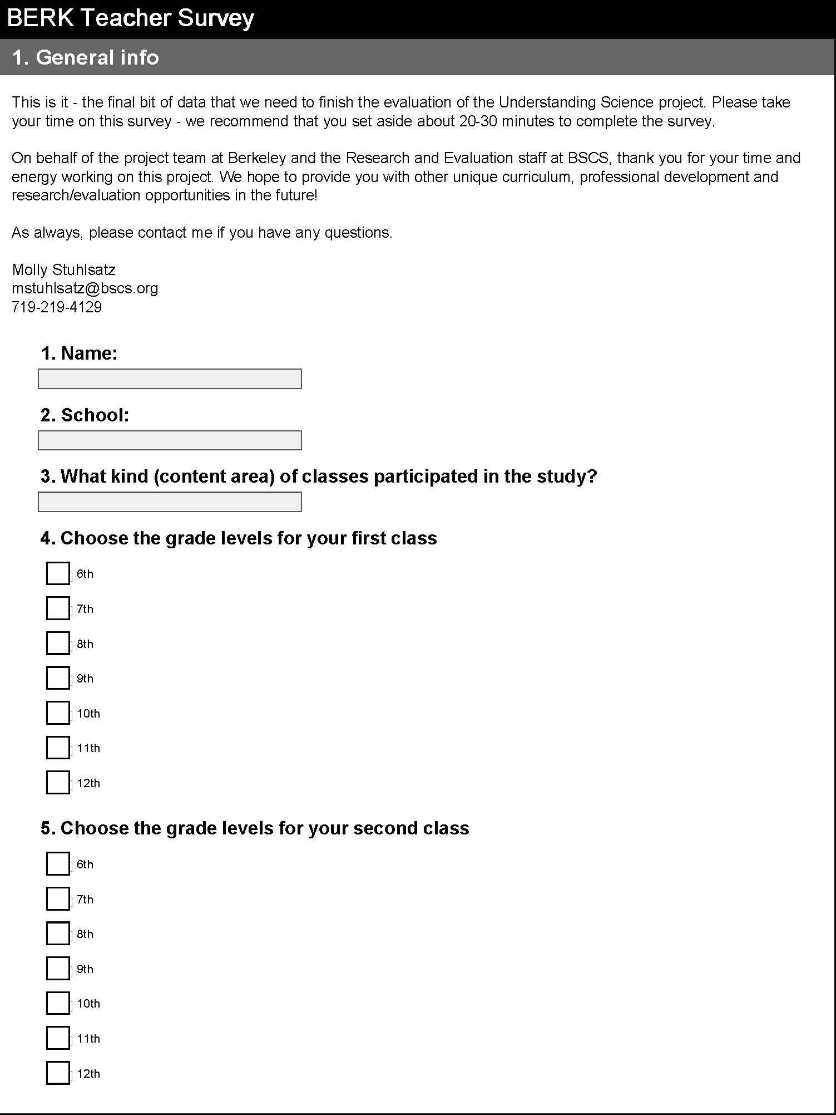

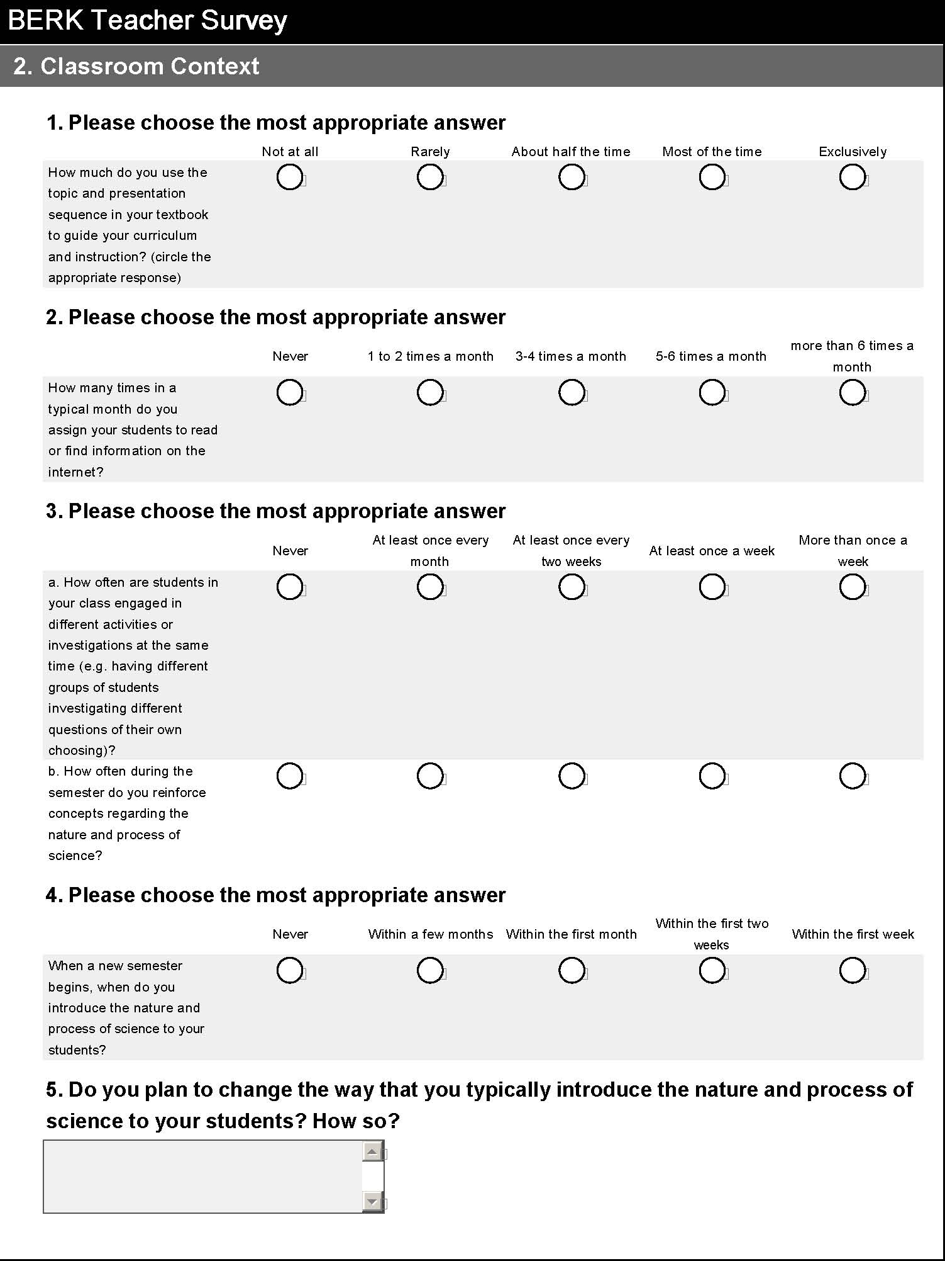
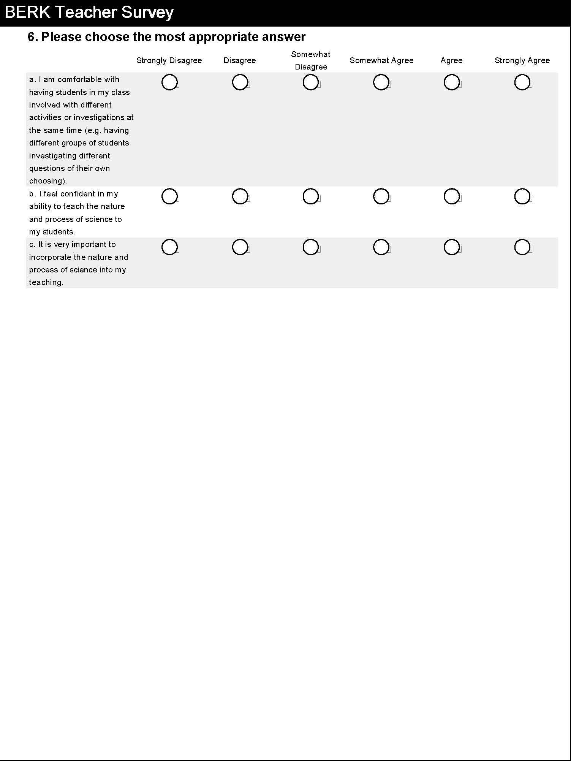
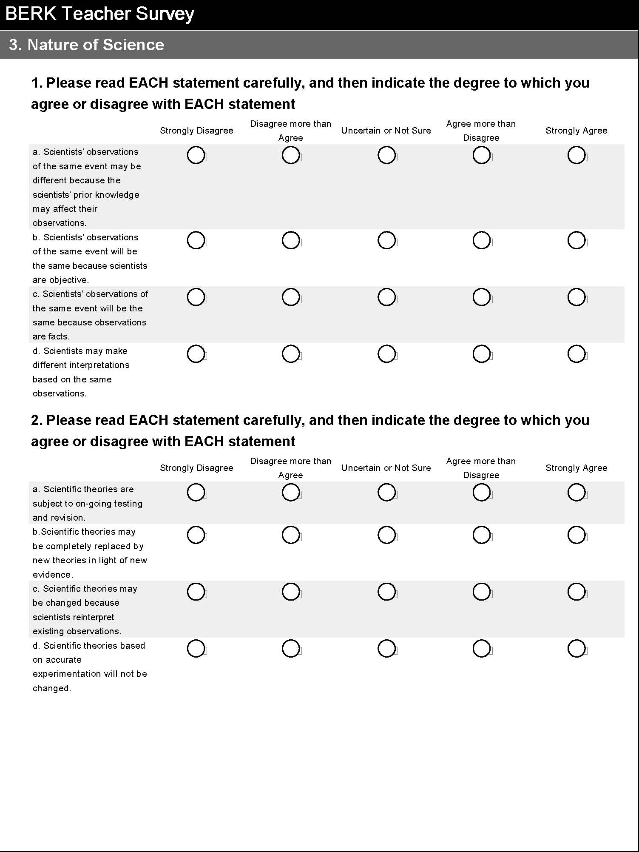
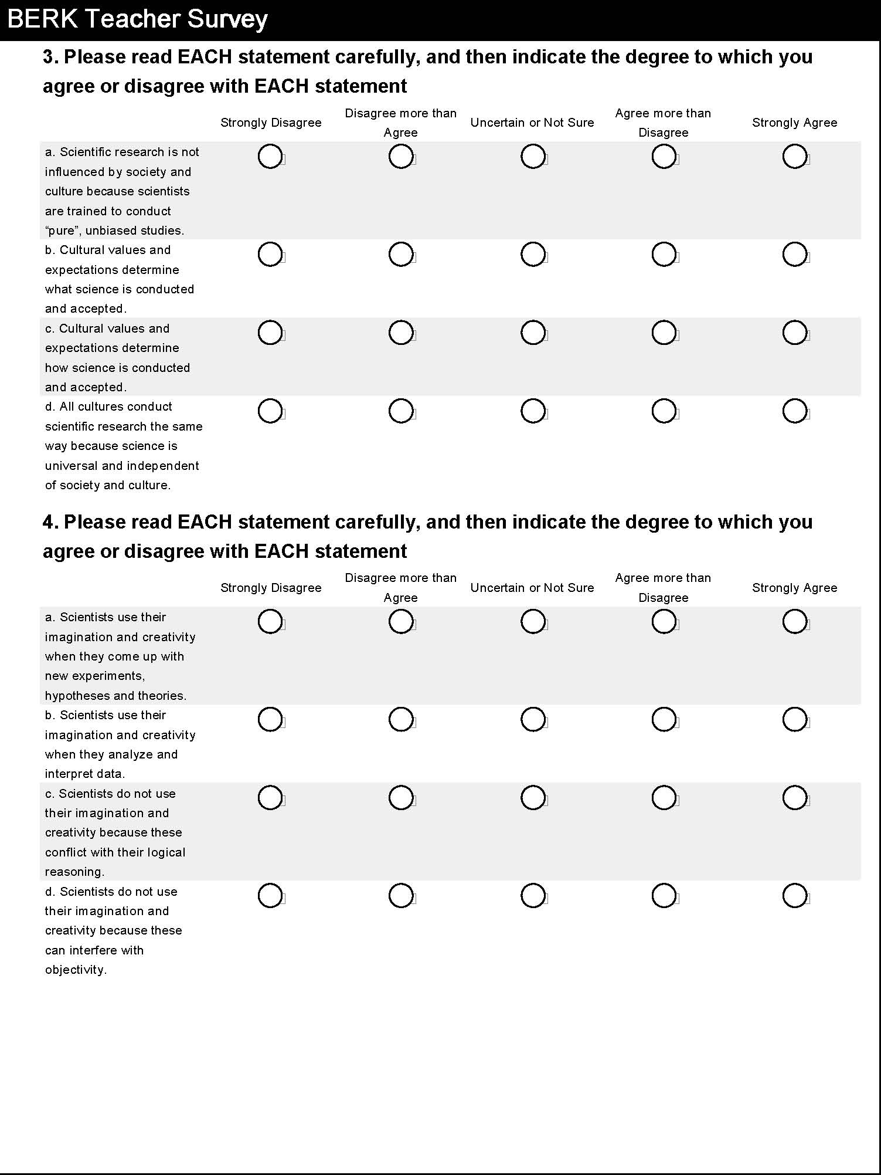
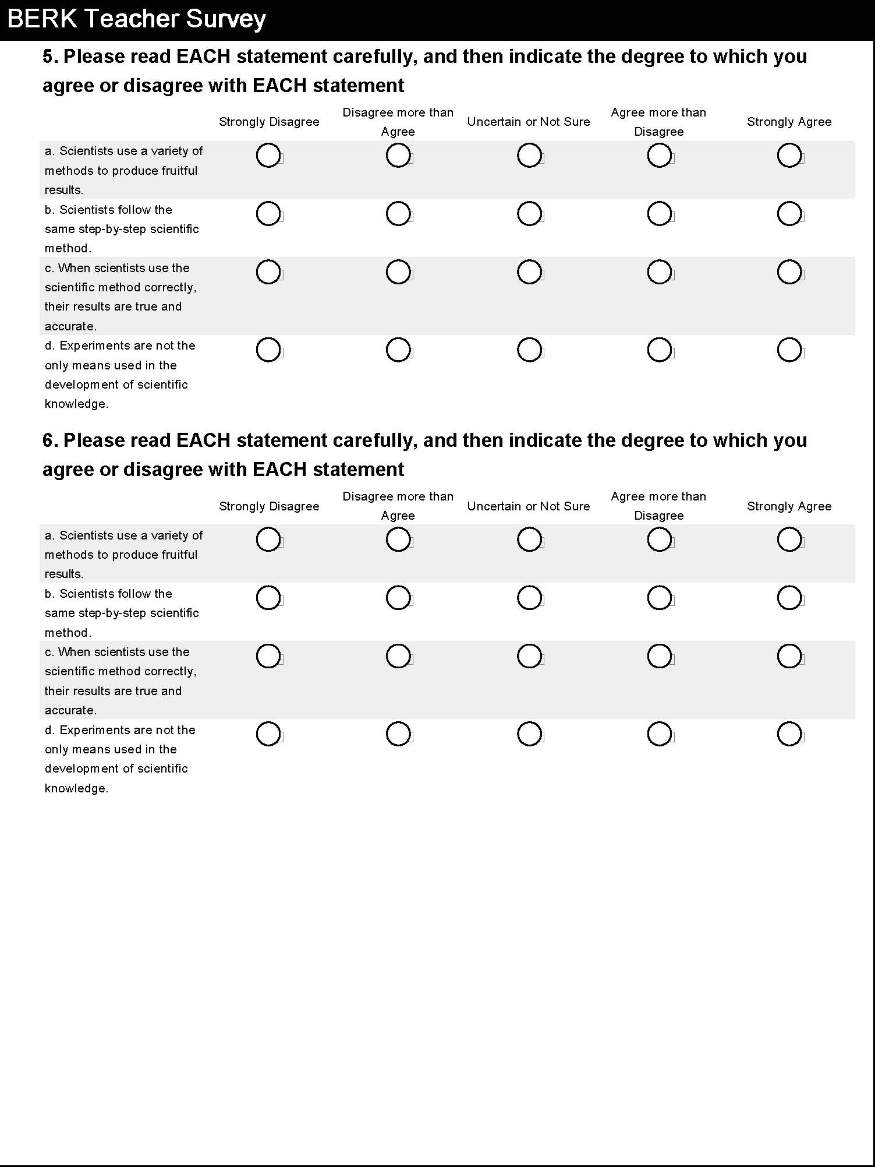
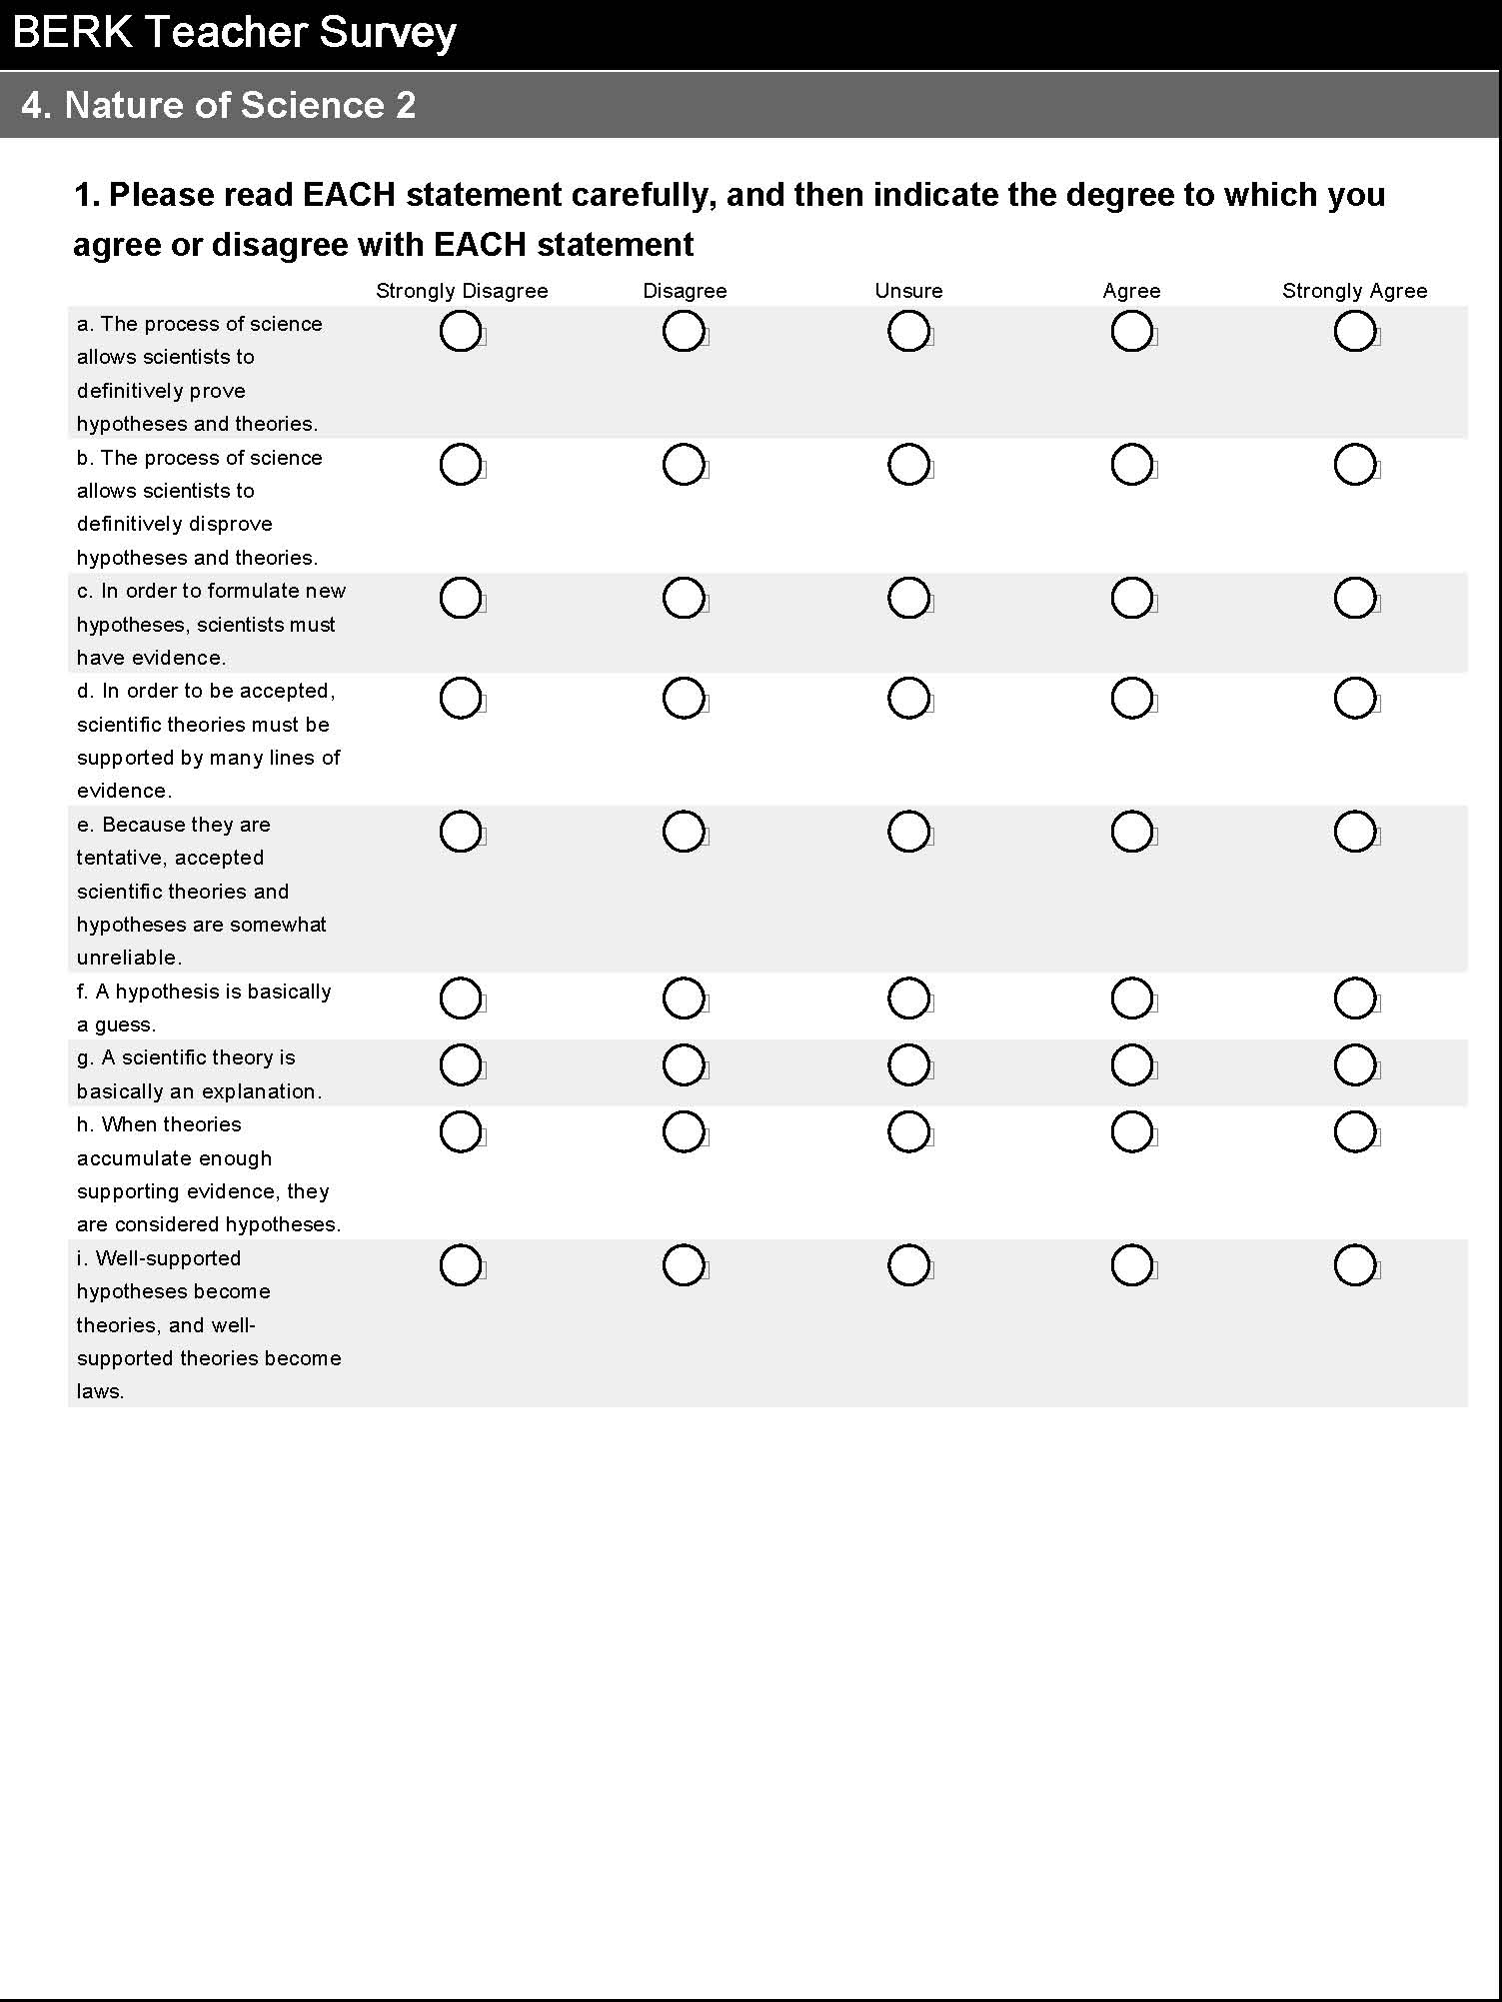
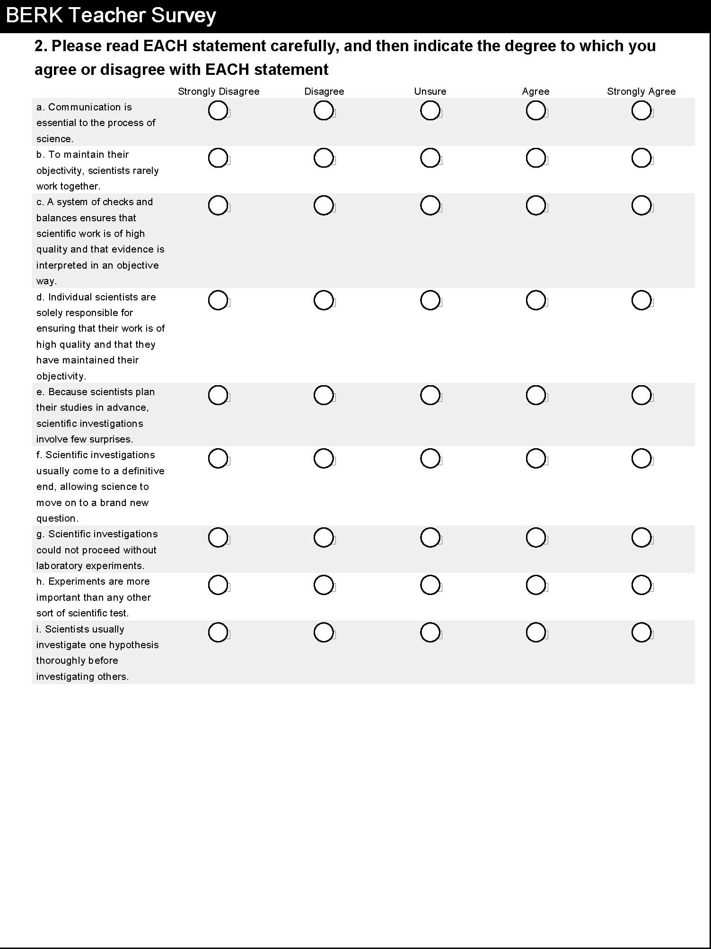
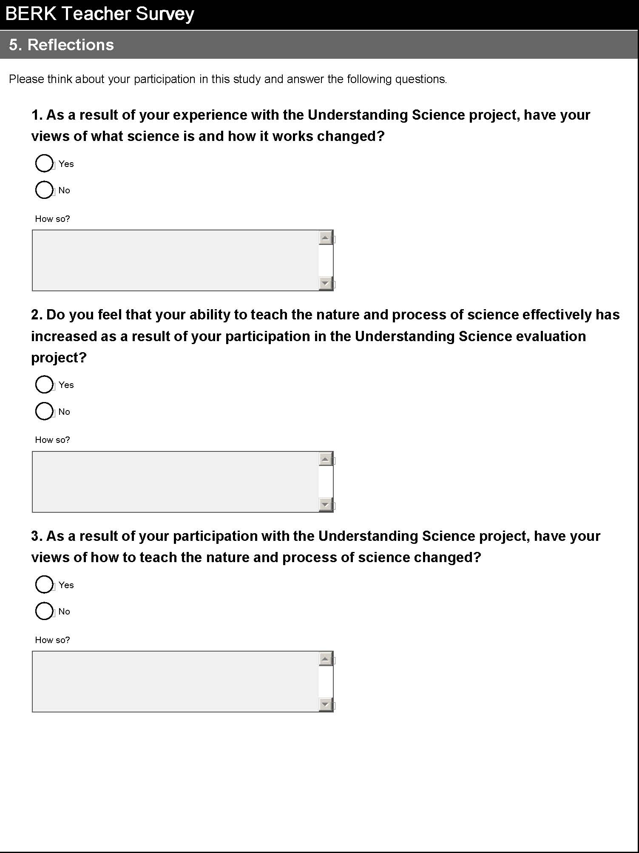
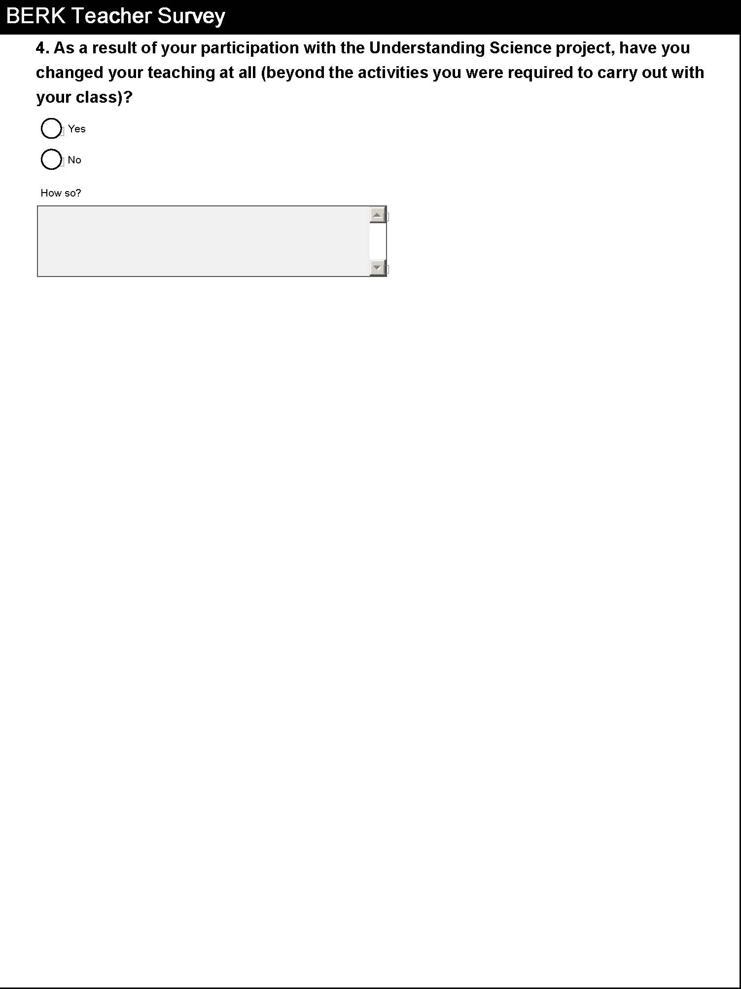
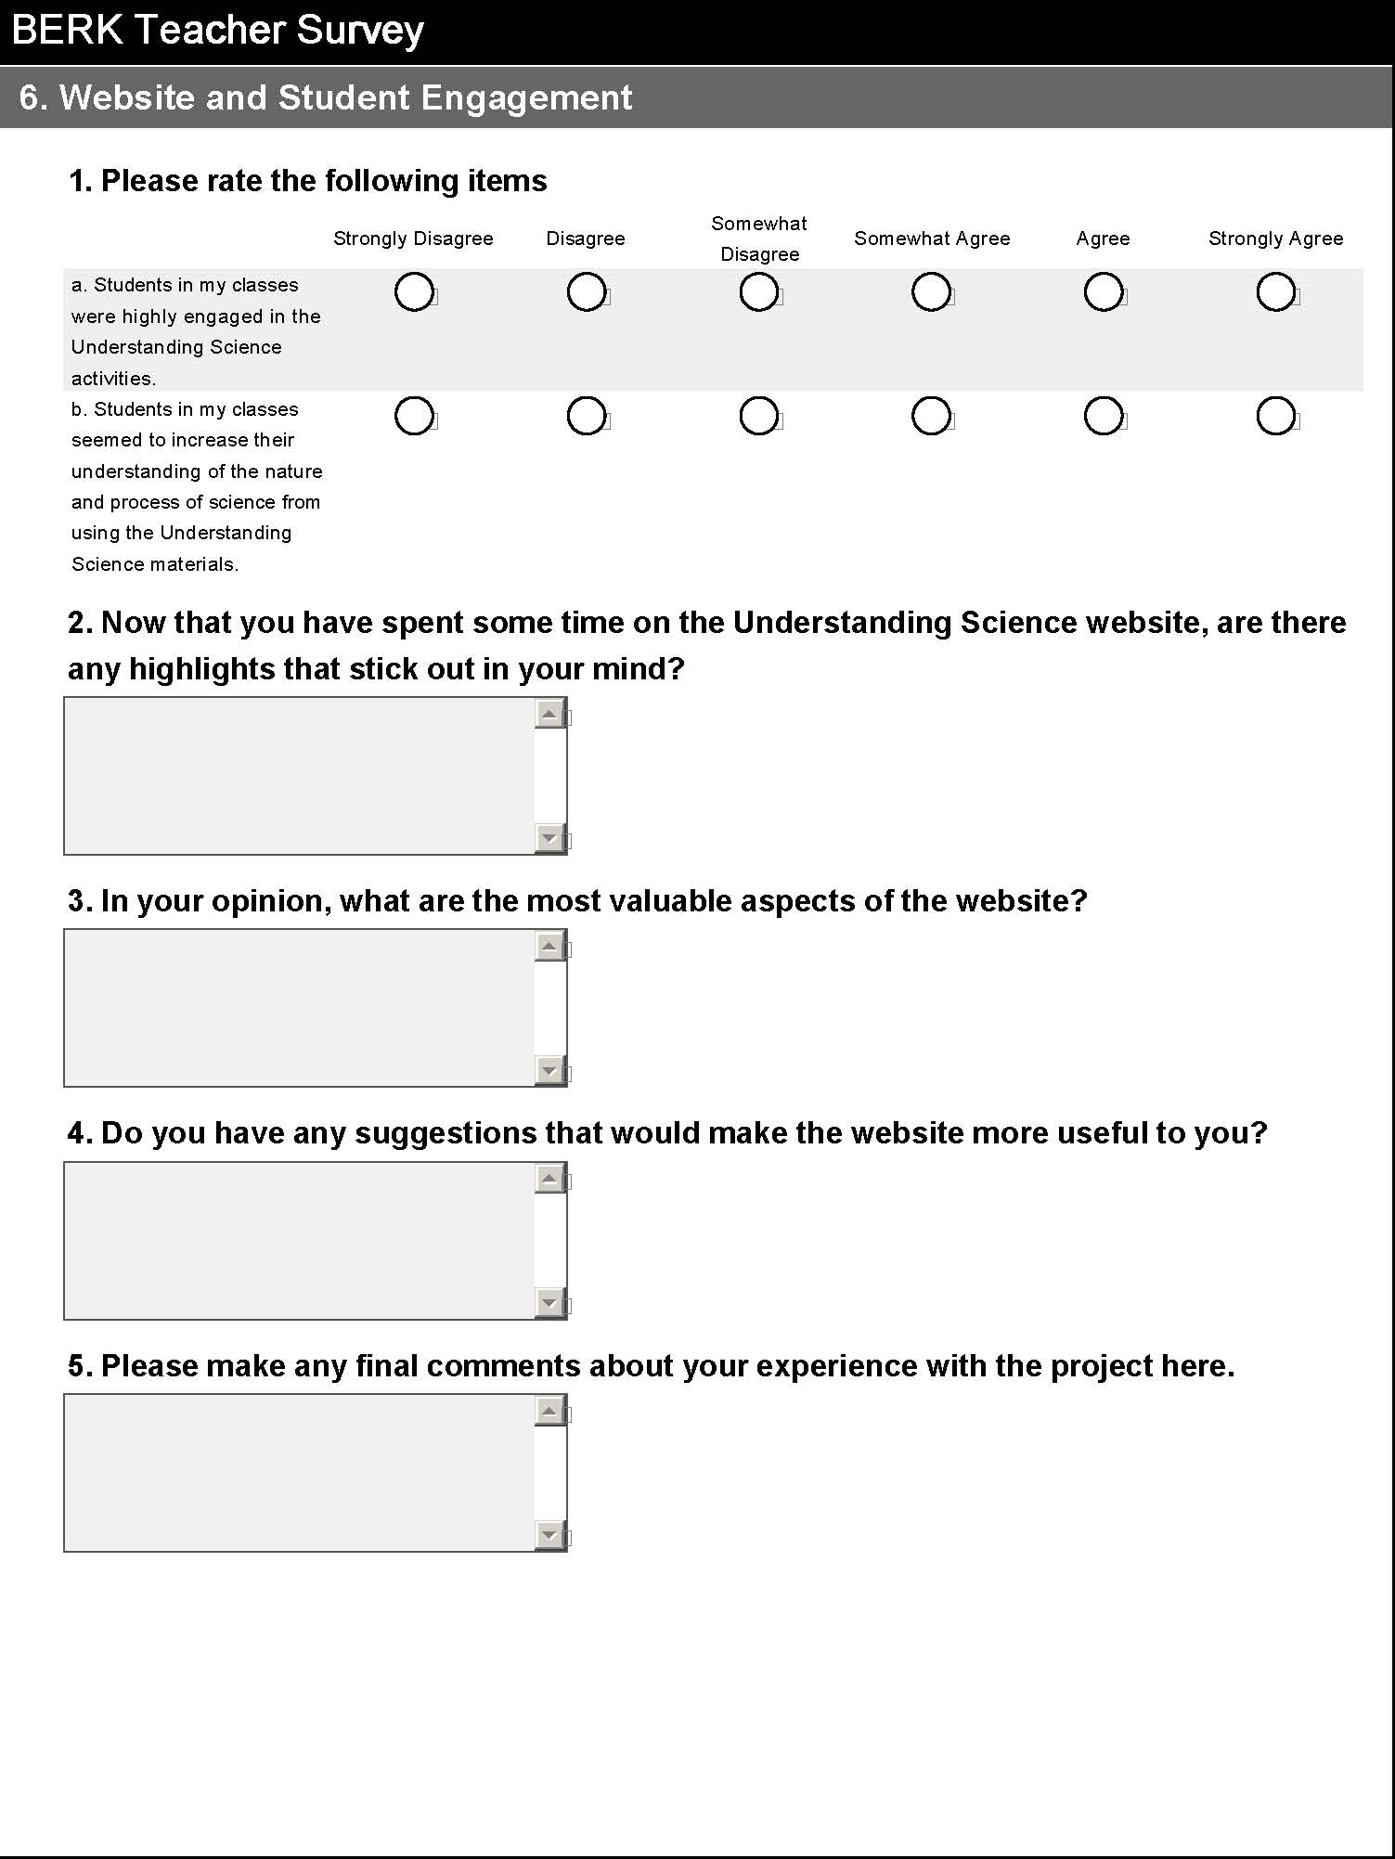

Appendix E: Transcript of Focus Groups

Middle School Teacher= MS
High School Teacher = HS

Aside from the protocol from the evaluation project, did you make any changes to your teaching based on US?

HS
I have emphasized making things explicit to the kids. Connections between data and what they are supposed to get out of the content.

MS
With the groups that I’ve worked with this model I did a lot more of describing How Science Works. In a more circular way, trying to get away from the straight linear – scientist has to find a problem and form a hypothesis. Especially with that bouncy ball exercise. The way that I proposed it was just the way that we saw it. Took them to the cafeteria and “you are all junior scientists and I want you to gain knowledge.”

MS
I’ve been referencing it a lot in the labs that we do. I reference that flow chart

MS
I felt it was reinforcing a lot what I do at the beginning of the year, thinking like a scientist, and how does that look. My class has journals and the kids really start owning them and they are really looking like a nice document that belongs to them and nothing is torn out or erased. If anything this project reinforced how I’m teaching and how much time I take to go over what does a scientist look like, sound like.

MS
I kind of teach the same way, but now I’m really saying “how are you acting like a scientist?” I do it a lot more frequently in the classroom and I think the kids become a lot more aware of what they are doing in the classroom.

MS
When the kids did the article on ozone, because we were doing a unit on climate, so the article is just perfect, they really got into the process of identifying doing scientific work. It did a great job of helping them use some of the words like “reflection” or “question” or “data.” I really liked that assignment.

HS
I’ve used it as a springboard to their honors project, so it’s impacted how I present the honors project. The experiment that they will concoct second semester, this is a nice springboard for an open-ended experiment. They tell me that they aren’t as daunted in having to develop an experiment. They have to identify a purpose and getting a testable question is really tough for them.

MS
I know in IB they start with data collection and analysis, but coming up with their own problems and figuring out what their variables are and what their question is can be difficult.

MS
From a teacher perspective it takes some getting used to working this way especially on assessments because you can’t just zip down the page using a rubric to grade things, you have work a little bit harder. In the past, most of my inquiry teaching came out in my questioning strategies and not in my assessment. You have to think a little differently, but the kids will naturally go that way.

HS
I just kept bringing it back up – don’t forget the flow chart, don’t forget that science is messy. I kept reminding them that they may be frustrated at the end of the lab because they might not have an answer.

MS
I just kept trying to get it across to the kids that the answer doesn’t matter – they don’t want to go through the process, they want the answer. The smarter kids especially just want to buzz through it and I think if they do that they miss science, they just get an answer they don’t see the process. Now I have the flow chart as a reference – I hang it up in the classroom and refer back to it. It gave them a visual.

HS
I spend a lot of time talking about NoS – so I was really surprised when my kids didn’t seem to have a conception of what NoS is. Trying to get them to shift from the scientific process is really hard. Even when we did the flow chart – we used the asteroid article, it was really hard for them to feel comfortable with going in all different directions. Also it’s apparent to me that they don’t want to think. The step-by-step process doesn’t really lend itself to thinking. We had some good discussions. It was painful for kids to move out of what they thought about science to looking at how science works.

MS
The kids still have to report their information so we started talking about the difference between the scientific process and their lab reports. You still have to have the “parts” in the lab write-up even though the process wasn’t linear. I’d like to focus more on the process as well as how you report this particular activity.

MS
When we did the asteroid reading, they highlighted stuff, and you give them direct instruction, you somewhat get the same results. When you ask them to do it more freeform they get lost. Once I had a teacher who would have us write about whatever popped into our heads at the beginning of class – for a long time I didn’t understand why he did that, but now I realize that it’s about not being linear, our minds don’t work that way. When I had the kids do it they realized they don’t have to think a, b, c.

HS
We used the short DNA article on the website using the science checklist. Now I’m going to have them read the long article. I think this is going to help them make the transference that science is messy – and now we are going to go back to an article in Nature that is very much that format. Where they are going to go, I don’t know – but it will be interesting.

MS
I really focused on the process being nonlinear. I did this with my two lower classes and they struggled with the asteroid reading. I did it with them – they didn’t really get it. They had a hard time connecting the reading to the flow chart. It’s been pounded in their heads that you have a question then a hypothesis and then you collect data and then you have a conclusion. So they had a really hard time breaking out of that. They really liked picking their own questions and materials in labs – they got really excited and loved that they got to experiment with their own questions. With the bouncing ball activity I didn’t have all the materials so I relied on them bringing their own materials. Even the fact that we had to say the word “balls” became an issue. The materials were an issue. I struggled myself with letting them ask their own questions, even if wasn’t the best scientific questions. Then I had some kids that were really great – they collected data and asked their own questions.

MS
I would talk to them about how it wasn’t linear. But on the CSAP they still have to remember the “6 steps.”

HS
They have had the steps so many times. But with the flow chart it has really opened up their minds. They are so turned on about the process.

Did you, or have you used any of the US activities besides the ones that were assigned from the

MS
I used the dogs and turnips. It was fun, their sentences were so different. They all made good sentences.

HS
We did that one too as part of the protocol.

HS
I tried having my students take notes on a video on ash fall. It was a video of a scientific discovery and then tried to have them chart it. It didn’t work so well, but it could have been because we had a sub for part of it. It should have worked, but I need to refine.

MS
Even the lower readers struggled with the Alvarez article.

MS
I did a video that I found of a discovery of hominid fossils in Indonesia the title of the video was “Aliens from Earth” and we asked the question “was this a separate species” and they took notes and every 5 minutes or so we would stop and I’d say “who votes that this was a theory or is it still a hypothesis” and we went back and forth and the votes went back and forth. I’m not sure if they were swayed. But a lot of scientists agreed that it was a separate species and a lot of them disagreed.

MS
I haven’t taught specific ones but I am

HS
I taught the DNA one.

Why did you select the additional activities?
MS
Dogs and turnips looked like fun.

MS
It reinforced language arts in science, as well.

MS
I’ve made the tubes, but the ball activity might be hard for 6th graders.

MS
I thought it went really well – I just asked them to think like scientists and I want you to put together some type of investigation using these balls. Oh, they had a blast, they loved it. In fact, we have 90 minute periods and they asked if they could do it again using another variable. I’m hearing them add scientific language to it, they were using tape measures and meter sticks. What I also loved was the ones that chose that totally was not testable and they worked and worked and finally got to a point where they realized it wasn’t going to work and they restructured and did something else and that was probably the most exciting – seeing them realize this is not going to work. I also had them record their data in a graphic organizer and turn that in.

MS
I didn’t do the ball one, but I did clouds, where kids make clouds in bottles, and I had them change variables and we had a class discussion about that. We made a list on the board of different variables that they could test.

I did something else – It’s a hoax movie about the flat earth and during the movie I had the kids write down weather is twas good or bad evidence. And then they had to develop arguments using evidence. It went over really well, but the reason I taught that is we were going into “Reasons for the Seasons” so the rest of the unit that I do will go into what evidence do we have that the earth is round.
HS
With the DNA – it sets the air for talking about DNA. The roll that it plays in terms of everything else. We can talk about that and show them how people got to that understanding.

Did you have any challenges?

MS
Dogs and Turnips – some kids got frustrated. They would flip them over too quickly.

MS
Building the tubes was challenging, but now we have them forever!

A few people made tubes.

On the small roll, I gave them a paperclip for the middle.
The kids were on task the whole time.

The questioning strategies are really important with the tubes.

Why haven’t you done any more activities?

HS
Time crunch

MS
Time is definitely the issue. What I’ve done instead of the activities is that I’ve taken what I learned from the class and put it into the activities that I have to get done. An example is reasons for the seasons – modeling using balls. The conversations are fabulous – they had really rich conversation. Finally someone said “the golf ball could be the moon and now we can see the phases of the moon.” I felt even better about not using the alternative lessons because I didn’t have to feel like I was skipping over content that I have to cover. I instead started putting the concepts we learned into class.

MS
I really try to teach activities with content – she will do later and write down on the log sheet.

MS
These things can be used in a variety of ways.
You could use it for plate tectonics.

MS/HS
Time is the biggest restriction right now. Next semester should be better.

What are your plans for the rest of the year in terms of your NOS teaching and specifically, do you feel like you will be making changes to the curriculum that you would have taught that have been impacted by the workshop?

MS
I will be doing less of giving a linear cook book for the scientific method. The scientific method is not going to be what I specifically teach. I will use the steps of a formal lab report.

MS
Next semester I’ll be doing all physics related stuff and we can use this a lot with the labs.

MS
Our IB coordinator is really interested in this because it matches IB really well.

(small discussion about IB and getting credit)

HS
We can change the way we approach the curriculum. So I’m not going to change the curriculum, but I think that we have a hard time with analysis and presenting it on the one sheet write up like on the bouncing balls – presenting it as a “what’s your explanation” – maybe something as simple as that may be a bridge to finding ways to get them to analyze. To get them to use their data in a thoughtful way. To look for patterns and so that would be one of the things that I will do second semester.

MS
6th graders go to Challenger Space Center – We could adapt the flow chart to that “mission”.

MS
Using journals to write about how they were acting like a scientists is really helpful. Writing and reflection is perfect.

MS
What I appreciated after this class – I also teach a language arts enrichment class – so I had my kids read the All Pikes Peak Read – Rocket Boys it was really cool because we were talking about thinking like a scientists and how does that look and we were doing the same thing, using the same language in language arts. I loved that, it just bridged into the language arts class. When they journal it they said “how many failures you can have but stay with it.”

MS
I’m going to make more changes because I’m seeing some of the kids starting to think! Sometimes we bind our students and they need to be turned loose. I’m going to continue with trying to push them even more. The process is important. They need to feel like the process is ok.

HS
I will continue to do some of this – it’s hard in chemistry – but I am letting them decide more about what they want to test. Yes they are more engaged and yes they are more excited about it, but it takes longer. I will refer to the flow chart more regularly, but we can’t make everything longer and there is some basic factual stuff that they have to get and not everything lends itself to inquiry. It would have to be less open-ended. It takes longer for them to come up with what they want to do and for me to ok it. There is a certain amount of stuff that we have to get through. In POGLE there is some really good evidence that kids know less but they learned it more thoroughly.

MS
The thing with doing things different – I need to find a way to un-condition myself. What I did is I took things a little further by mixing up the variables and gave groups different things to work with. I need them to think outside the box.

HS
I think it’s ok sometimes to leave it there – sometimes there are answers and sometimes there aren’t answers. They need to know that they may be the ones that have the answers to the unanswered questions, but they have to know how to get there, they have to be able to think through them. That’s the problem for some of my students – I’m going to be fostering better thinking. I’m not sure exactly what that is going to look like.

HS
One of the things that I liked about the activities too was that even though it took more time you did get a chance to hear more from kids and that’s something that doesn’t always happen and you get a sense of where they made a connection and if they didn’t quite make the connection you can go back and say “what can I do differently to help them make that connection?”

MS
It’s tougher depending on the subject matter – with evolution it’s kind of hard, they can’t do a lab on that.

HS
All of my students have to do a science research project and I’m going to use the site as a reference for them. It’s a good tool for teachers to use and think about as you plan. Especially the part about how to modify lessons.

MS
I’m going to use some of the activities to get them ready for their science projects.

HS
I’m going to take what I’ve learned with the first two classes and use it with my other classes.

HS
We are lucky because we have 4 teachers in the study and I’ve got chem., they’ve got ES and Bio and Physical, if we can do this every single year in high school they better not be saying “what’s the nature of science” by the end. We don’t do “what’s a hypothesis” anymore. In regular chem we need to go back to what’s the process not just the answer.

How did your students react to the US activities?

MS
Anytime they get to change a variable and test it on their own, kids get excited. They are always wanting to change variables based on the gears on their heads turning. My kids get really excited, they really love it. They seem to think more and process information more.

MS
The kids that like the worksheets that like to go from A to B, they have trouble with this. What’s the expectations? Is it okay that I’m thinking in this direction? They haven’t been asked to do that before, it’s new thinking for them. They have fun with the activity but as soon as they have to do the write up they’re dying cause they don’t know how to do it.

MS
One of my higher level classes, one kid was taking his group under his wing and he was very intent on following the scientific method as I had started last fall and he had to have a hypothesis and his data all in order and he was so intent on getting that he wouldn’t even stop to listen to what the other kids were saying because he knew he had to turn this in. So that was interesting. One group did different tests. Most of the groups just measured the height of the rebound, but one group did start counting the bounces. Also, I had demoed it on a table and I used a golf-ball, which was absolutely dead on a table, but when we went into the cafeteria on a tile floor, the golf ball was actually bouncing. So they really started thinking.

MS
It would have been interesting with the tubes to have someone listen to the groups and document how many times you heard a hypothesis type question. And I’ll hear a ton of them. It would have been a nice thing to document that.

HS
It would have been fun in the labs to have an observer. I didn’t do that, but I think I will next time. It would be fascinating to see how the observer reacted. I think it would be really interesting to try. It’s so different, the beasts, the little hormones pulsing through their veins. In 9th grade it’s like pulling teeth to get them to record things.

MS
Using journals is a trained thing. Just the fact that they are thinking and processing and writing things down.

MS
The lower readers do have trouble reflecting.

MS
You could have them draw pictures?

MS
I let them use their journals on the test so they write more information in their journals. Use it for just reflections.

MS
That might be an interesting behavior control too, because the people in the group wouldn’t know exactly what the observer was looking for. Call them behavior tubes.

MS
They were kind of Aha! When they got the flow chart. They had been thinking so much in the scientific method that they kind of realized that it wasn’t so “step 1 do this, step 2 do this”. Some of the really low kids we laminated the flow charts so that they could draw on them with dry erase markers and now we can use them all year long. Some of the low kids we walked through it together and they were surprised by a zig-zag pattern.

MS
Did you ever go back to the original sci method and compare the two and ask them how they are different?

MS
No, I didn’t but I should!

MS
I wonder if the kids would like this way better?

HS
The fact that they got the same posttest, they thought it was a huge mistake.

HS
I used a “Finding Fossils” activity from the ENCE? Website – they really liked that. It was problem solving. When it came time to report out and make meaning, one of the questions asked them how was what they were doing like a working scientist and I want you to know they had a hard time figuring out what that means. I was in shock. It’s not the doing that’s the issue, it’s what does it mean that’s the issue.

MS
Are we fighting a conditioning problem? They don’t care about the process – are we having to un-condition them? We call that thinking. We had to do that.

MS
It’s not just the kids and parents, teachers are conditioned too! It’s a whole societal thing. Why do we give state-based tests? To get the right answer. It is conditioning. It’s hard enough to get someone to change one aspect of their life, let alone a way of thinking.
It seems like the kids with the more flexible parents are the better thinkers!

HS
If the literacy skills aren’t there, it’s so hard for them to decipher what they are doing.

MS
Modeling is really important.

MS
It took us nearly the entire class to do the word fitting exercise. The smartest kids in the class had the hardest time. “It doesn’t fit” they would say.

HS
The checks activity was hilarious. We could have done this for a week. The kids loved it, they loved writing the story. They were furious that I couldn’t tell them the real story. “What happened to these people?” They did not like that. There were some stores that were West coast stores (the names of the stores they didn’t know – Vons?) and the NOW – it’s not something that HS kids are familiar with. So at the end I asked them “what does this have to do with science” and this one girl says “Well, you don’t always have all the answers. It was like – did I pay you?

HS
One of my students didn’t know what an OBGYN was. They made up all sorts of scenarios.

MS
The mystery tubes were great for me. When I loan them to other teachers in the building I make it clear that they are not aloud to let the kids know the answer. They cause inquiry without an answer.

What did you students think of the flow chart?

MS
I did run into some language issues. What does it mean “opposing hypothesis?”

HS
It’s hard to break out of this is the way it should be because it has been taught. They’ve been engrained into them. So trying to discriminate between what they know and this new way is hard for them.

MS
Maybe if they did it a couple of years in a row, they would be more accepting of it.

HS
How do you evaluate that? What is this going to look like to me as a teacher when it is a lab report or a write up. What is it going to look like for us in that next phase?

MS
What if it was a hybrid or the two?

HS
(Discussion about assessment)
Logistics of assessing students
Reflection piece rather than during the task

MS
I struggle with teaching NOS because what if my students move on to another teacher who doesn’t teach this way? In high school or college? I think we have to look at what are goal is, is it that we want to totally change or just be aware that this is how science works? You don’t have to do it with everything.

MS
I think we can have the best of both – I mean we have to have labs where we follow the lab write up for 6th or 7th grade. But I think it’s okay to blend both of these together. I think what I’m taking from it is yes I want them to be able to function in that teachers class who does more of a cookbook lab and wants a formal lab, but in the meantime you have kind of sparked that thought that they need to really think and react like scientists. I have to say that when I did Reasons for the Seasons this week I told them, I don’t want a hypothesis, I want you to start with a really good question and they were like “YES! We don’t have to do hypothesis.” And by writing their question they did a hypothesis without even knowing that they did it! I just think they struggle so much with writing a hypothesis I’ve enjoyed just backing off and saying “give me a good question, what are you trying to find out.” So I think you have to have both. These kids are going to go to different teachers.

MS
You have more pressure at high school. Your dealing with so much different testing. It’s tough.

HS
It’s just an interesting thought, because we’ve been conditioned as well. What would this look like?

MS
When I first started learning about this stuff I was thinking to myself “do I have to do this all the time?” It’s not like you have to revolutionize every activity.

MS
The simple flow chart they liked

HS
Oh for my kids the simple flow chart didn’t have enough meat so we moved to the more complex one. The more complex one worked better.

MS
There was too much in the complex for some of my kids

HS
My 11th graders took about 40 minutes to read the article, and translate it to the flow chart. So I had to wait until the next day to get them into the groups and defend. We used the complex one. One kid had 1-20 and another had 1-78.

MS
I had some kids that would just highlight “science words.”

HS
I had to tell them to look for verbs

HS
I had to help them identify what words represent scientific processes.

MS
The kids didn’t know how to connect the article to the flow chart. I told them that they were making a web, everyone’s is going to be different. Even though we did most of it together, they didn’t really get it.

MS
We had to read the article together. There’s a clip on discovery net about Alvarez and that really helped the kids understand the reading.

What impact do you think the US activities had on your students? In particular did you notice any differences in their thinking about what science is or how science works?

MS
The big difference is when they did the ball activity. I’ve given activities that are cookie-cutter. What I tell them is that they have to read, they have to figure things out themselves. What I liked about the balls is that I saw them get engaged so much faster than when they read an experiment out of the book. It’s an ownership thing. When I give them an experiment its my experiment that they are trying to figure out. But when I gave them the materials they owned what they were doing. They were a lot more excited. I heard a lot of good interaction and good discussions right away verses if it was my experiment. And then they would always be asking me “is this the way you wanted it?” instead of asking each other. So I was happy when they were interacting at that level.

MS
After we had each group reporting on what knowledge they gained. I asked them “If you used these balls again, what would you want to do?” They said I’d want to do it on wood, I’d want to do it on…

They wanted to share their information. Everybody wanted to share what they did and what their results were.

MS
My kids were really engaged too and when I had them draw what they thought [the tube] looked like on the board they were commenting on everyone’s.

MS
When you have discussions on the tubes the child feels like there is less of a risk in saying what they think is in there. They know it is alright to change their idea five minutes later. The ones who are more timid are apt to get more engaged.

MS
Yes – they aren’t looking for the answer quite as much, they are discussing more. The downside is that it can quickly turn into social hour. We have so many spot-reviews that we have to clamp down on that. I’m seeing positive results though.

MS
I want to see the long range data.

HS
Hopefully we’ll see that in the CSAP scores!

MS
That’s the first thing that my administrator told me – is it going to do anything to hurt our CSAP scores? What about CSAP – what about standard 1? I told her I thought it was going to help. She didn’t care about the demographics, just CSAP.

HS
One of the things that we struggle with in HS on CSAP is the short constructed responses and this is something that should help them think and write. I’m thinking that there will be some return in that part.

Did you have any challenges or activities implementing the activities?

HS
No, my teammate got one activity ready
We work together and one did one part and the other person implemented

MS
Load time setting it up – the first time takes longer. You can put it in the files and have it ready the next time which makes you more likely to utilize the activities in the future.
We used the poppers (hoper poppers) instead of the balls – we didn’t have to go out and get the balls.

HS
We have a cube lab – phenol-phaline auger cubes – 1,2,3 cm cubes and they turn colors. Large surface area to volume ratio. Students built an experiment around it. Kids were finding out all sorts of interesting things when before it was a boring lab. Some kids came back and thought they didn’t do a very good job and wanted to try again. They really like reporting to each other. Everyone talks – it’s good.

HS
Part of it is us becoming comfortable with this type of teaching.

HS
It takes more time. And it should. You have to figure out how to address the vast content of what needs to be done in biology. It’s the inch deep, mile wide. Is that okay? Nobody knows the answer. We have 10 different sections of biology – is it alright that different kids are cutting different sections? That’s the huge dilemma.
We knew we needed to do something different and it took us forever to cover the content. We have run out of time for other things.

HS
I had my kids tell me on a scratch piece of paper during the checks activity tell my how they were feeling. During different times in the activity they were feeling happy or frustrated, etc. When a different group pulled out a different set of checks there was a huge conversation about collaboration. That really helped for the checks lab.
Need to make the checks less geographically specific.

HS
In order to keep them focused I gave them some different parameters. If they were leaving the classroom they had to tell my the reason (surface difference) and they had to give me quantitative data.

MS
I struggled with that (bouncing balls) in my classroom because the instructions indicated that they could do anything they want, but for my kids that didn’t work, I had to give them some parameters.

HS
We wrote questions on the board. We scratched off the board 5 or 6 questions that weren’t going to work.

(Perhaps there is some difference between implementing the bouncing balls activity with MS and HS students)

HS
Only one group used the balance with the bouncing balls. They didn’t want to talk about mass.

MS
With the mystery tubes they just thought it was a puzzle – they didn’t think it was science.

MS
With the lab I made up, I found that they did really well coming up with questions and used the thermometers a lot and timers. It seemed like they were more quantitative with the dry ice (that experiment) than they were with the bouncing balls. I think that if I did the bouncing balls again, I would do it differently. But again, it was a struggle of – they want me to leave it open-ended that they can ask their own questions, but it was going to be a disaster. I knew that part of the project was letting kids ask their own questions.

HS
I really think that having a context is important and that the US materials help to give a context and if we have a context we can do a better job. Not all questions are scientific – using the science checklist will help them figure it out. They can judge their question by the criteria. I think that we have not been clear ourselves about what we want kids to do.
What are we trying to foster – what is it supposed to look like? The activities are taking shape.
Now that you’ve spent some time on the website are there highlights that stick out?

MS
Scavenger hunt for fossils. A lot of them were just the click through the different slides but to find the mountains they have to go through lots of stuff. It worked great for our 7th grade fossil unit in Earth science. Superposition, layers, index fossils

MS
I haven’t looked extensively. I want to use it for physics.

MS
Both of the websites look user friendly and well organized. I could find what I was looking for quickly.

I’d like to go back and take some more time to look at the website.

MS
I told the kids to Google geologic time

MS
On the evolution one, they have a great fossil record. The kids could have a great time looking at the fossils.

Did anything strike you as particularly valuable (from the website)?

MS
There’s some really interesting stuff on the blog looking at what the other teachers that have used the stuff think.

HS
I’m going to dutifully check the website after the holidays.

HS
I like that there is a continuum, you can see how the process works?
The teachers resources – the links – you can go to where you need to go from the website. The modified and exemplary lessons are good.

Do you have suggestions for improving the activities?

HS
I don’t really have any suggestions – the dogs turnip thing and then the bouncing balls with poppers. I like the format of the squares – the modifications part really freaked them out. They had the idea that they did a good job because they didn’t feel like they needed to modify.

MS
With the bouncing balls you can do so many different things (questions). The poppers seem like you could really “guide” them.

MS
With the ball thing – if the kids are kinesthetic, they have a hard time keeping in control with the balls. I had to take them away until they were ready to do the experiment.

MS
With the articles – ozone layer article might be nice to have shorter articles with a lower reading level. Have a variety of articles with lower reading levels. The font was pretty small too.

MS
I’d like to see a variety of articles on different topics so that students go through the same process a number of times throughout the year.

I really liked the articles. It’s great to have literature for science that is readable. Short articles that cover recent concepts.

HS
They need more biology related activities and articles. They aren’t covering all the content areas yet.

MSN has lots of short articles about recent discoveries.

HS
I feel like I don’t know yet.

Do you have ideas for activities/lessons/strategies that would further US goals?

Website – INCE? They have a lot of activities for middle school.

SUNY Buffalo – Website (high school) case studies in human evolution. Case study on a knee injury – very open-ended flow. They would be presented with different parts at different times all student driven, the kids do the digging for the information. They have a ton of adaptable activities.

A lot of the science Olympic events in physics gets into the design-flow cycle.

Appendix F: Student Demographics Sheet

Student ID Number: __________________

Teacher Name: _______________________

Gender:
_____Female ____Male

Are you Hispanic or Latino/a?
Yes_____ No_____

Race/Ethnicity (choose one or more)

_____Asian
_____African American
_____American Indian or Alaska Native
_____White
_____Native Hawaiian or Other Pacific Islander
_____Other – Please describe____________________________________

What is your grade level in school?

_____6th _____7th _____8th _____9th _____10th _____11th _____12th

Are you on the free or reduced lunch program?
Yes_____ No_____

Do you speak a language other than English at home?
Yes_____ No_____ If Yes, what language do you speak?_____________________

Appendix G: Student Nature of Science Test

Student ID Number:____________________

Teacher Name:______________________

Nature of Science

Read the following passage, then answer questions 1-20 that follow.

Shantel watched a show on TV that showed that giant ocean ships were made of metal. She thought it was strange because she knew that metals sink. Just to be sure, she got a glass of water and found a steel paper clip. She placed the paper clip in the water, and the paper clip sunk to the bottom of the glass. Then she thought that different kinds of metal might float. She dropped a penny, a quarter, and a balled up piece of aluminum foil in the water. They all sank. At first, she thought the TV show must be wrong, and that the ships must be made of something besides metal.

Later that week, Shantel saw an actual ship. The ship looked like it was made of metal, so Shantel thought she must have missed something important in her original experiment. She wanted to know how it was possible for metal ships to float.

She read on the internet that objects float in water when they are less dense than water. She knew that density depended on the volume (the amount of space the object takes up). Then she had an idea. She thought that if she changed the shape of metal to make it boat-shaped, that somehow the boat might take up more space than just the metal did, and it might float.

Shantel took another piece of aluminum foil and this time, folded it into the shape of a boat. She put the aluminum boat in a bowl of water. At first, some water seeped in and the boat sank. Then she tried again, this time making the sides of the boat higher. The boat floated. Then she poured water into the boat. When the boat got too much water in it, it sank. Shantel decided that the density of the boat was not the same as the density of the metal, and that the boat was less dense than water as long as it was filled with air. She concluded that metal boats can float, as long as they have the right shape. This made Shantel wonder if some shapes floated better than others.

Items 1-4 refer to the following: Shantel first concluded that the TV show was wrong, then later changed her mind. How is Shantel’s experience similar to or different from how scientists conduct investigations? Please circle either “True” or “False” for each item.
- Shantel’s experience was different because scientists run one careful experiment to find out the right answer to a question. | True | False
- Shantel’s experience was similar because scientists often revise their conclusions based on new information. | True | False
- Shantel’s experience was different because scientists rarely change their minds. | True | False
- Shantal’s experience was similar because scientists usually carry out their testing alone. | True | False

Items 5-8 refer to the following: What can you say about the process Shantel used to answer her question? Please circle either “True” or “False” for each item.
- Her process wasn’t scientific because Shantel ended up wondering which shapes float best and scientists don’t end with a question. | True | False
- Her process wasn’t scientific because she should have made the boats before she dropped the metal in the water. | True | False
- There was nothing wrong with her process because scientists do many different activities to answer questions and might do the activities in many different orders. | True | False
- Her process was okay, but Shantel should have gathered information from the internet first, before dropping metals in the glass of water. | True | False

Items 9-12 refer to the following: Shantel made two boats: the first sank, but the second floated. What can you say about Shantel’s scientific process with the boats? Please circle either “True” or “False” for each item.
- Her process is scientific: scientists often repeat experiments many times | True | False
- Her process is scientific: in science, it always takes at least two tries before something will work. | True | False
- Her process is not scientific: a scientist would not have needed to make the second boat. | True | False
- Her process is not scientific: a scientist would have made the second boat out of a different kind of metal. | True | False

Questions 13-16 refer to the following: Shantel first wanted to know if metal boats could float. At the end of the experiment, she wanted to know if some shapes floated better than others. What can you say about Shantel’s questions and the scientific process? Please circle either “True” or “False” for each item.

- Shantel was not scientific because scientists try to answer questions, not make up new ones. | True | False
- Shantel was only scientific with her first question. Her second question was not scientific because she didn’t test it. | True | False
- Shantel’s process was scientific because scientific investigations often make scientists ask new questions, even after they find the answers to previous questions. | True | False
- Shantel’s questions were not scientific because scientists already knew that metal boats can float. | True | False

Items 17-20 refer to the following: Shantel conducted several tests. She tested whether different metals floated in a glass of water and whether she could make metal float by changing its shape. What can you say about the tests Shantel ran? Please circle either “True” or “False” for each item.
- Shantel’s tests were unnecessary because scientists already knew that metal boats could float. | True | False
- Shantel didn’t have to run the tests. She could have looked up the information on a computer. | True | False
- Shantel’s tests were important to show that she could follow the scientific method. | True | False
- Shantel’s tests were important because her tests helped her gain evidence to make an explanation about how metal can float. | True | False

Read the following passage, then answer items 21-28 that follow.

In the 1980s, scientists planned to build a Superconducting Super Collider in Texas to discover new particles that make up everything around us. The scientific community was excited about the super collider because it would have helped them understand a lot more about the way the universe works. Scientists from all over the world were working together to design and build the super collider. There were many different jobs to do, and no single person could do them all. The scientists shared their ideas with each other and made decisions as a team to make the super collider the best it could be. The project was very expensive. At first, they thought it would cost 4 billion dollars. By 1993, the cost had gone up to 12 billion dollars. The U.S. Congress originally agreed to pay for the super collider, but when the cost became too expensive, Congress changed its mind. They decided to stop paying for the project and the scientists had to stop building it.

Scientists were not happy with the decision because they thought that it was important for people to continue to make new scientific discoveries. Congress wanted to spend the money on a lot of smaller scientific projects instead of just one big one. They also wanted to keep spending down so that U.S. citizens didn’t have to pay any more taxes.
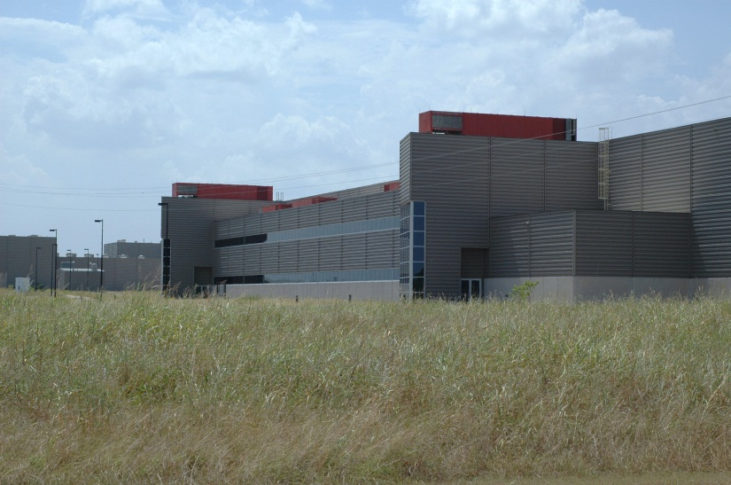

Photo of the Superconducting Super Collider (it was never finished)
Items 21-24 refer to the following: Which statements describe the Superconducting Super Collider project? Please circle either “True” or “False” for each item.
- The super collider project was not very scientific because the best science is “pure” and doesn’t get mixed up with society, money, or politics. | True | False
- The super collider project shows how society, money, and politics can affect science. | True | False
- The super collider project was not scientific because the super collider was never finished and successful scientific studies always reach a firm conclusion. | True | False
- The super collider project shows that scientists shouldn’t ask Congress for money for scientific projects. | True | False

Items 25-28 refer to the following: What can you say about the team of scientists who were working on the super collider? Please circle either “True” or “False” for each item.
- The only reason scientists were working together is because the project was so big and expensive. | True | False
- It is very common for scientists to work together as a team on scientific projects. | True | False
- The process was not scientific because the scientists were sharing ideas instead of concentrating on experimental results. | True | False
- The process would have been better if the scientists were competing instead of cooperating with each other. | True | False

Appendix H: Modified Attitudes Toward Science Inventory

Student ID Number:____________________

Teacher Name:________________________

The following statements are about the study of science. Please listen to, and read, each statement carefully. Use the following scale to show how much you disagree or agree with each statement. Circle the number that matches how you feel about each statement.

 | Strongly Disagree | Disagree | Undecided | Agree | Strongly Agree
- Science is useful in helping to solve the problems of everyday life. | 1 | 2 | 3 | 4 | 5
- Science is something that I enjoy very much. | 1 | 2 | 3 | 4 | 5
- I would like to do some extra or un-assigned reading in science. | 1 | 2 | 3 | 4 | 5
- Science is easy for me. | 1 | 2 | 3 | 4 | 5
- When I hear the word science, I have a feeling of dislike. | 1 | 2 | 3 | 4 | 5
- Most people should study some science. | 1 | 2 | 3 | 4 | 5
- Sometimes I read ahead in our science book. | 1 | 2 | 3 | 4 | 5
- Science is helpful in understanding today’s world. | 1 | 2 | 3 | 4 | 5
- I usually understand what we are talking about in science. | 1 | 2 | 3 | 4 | 5
- Science teachers make science interesting. | 1 | 2 | 3 | 4 | 5
- No matter how hard I try, I can not understand science. | 1 | 2 | 3 | 4 | 5
- I feel tense when someone talks to me about science. | 1 | 2 | 3 | 4 | 5
- Science teachers present material in a clear way. | 1 | 2 | 3 | 4 | 5
- I often think, I can not do this, when a science assignment seems hard. | 1 | 2 | 3 | 4 | 5
- Science is of great importance to a country’s development. | 1 | 2 | 3 | 4 | 5
- It is important to know science in order to get a good job. | 1 | 2 | 3 | 4 | 5
- I like the challenge of science assignments. | 1 | 2 | 3 | 4 | 5
- It makes me nervous to even think about doing science. | 1 | 2 | 3 | 4 | 5
- It scares me to have to take a science class. | 1 | 2 | 3 | 4 | 5
- Science teachers are willing to give us individual help. | 1 | 2 | 3 | 4 | 5
- It is important to me to understand the work I do in science class. | 1 | 2 | 3 | 4 | 5
- I have a good feeling toward science. | 1 | 2 | 3 | 4 | 5
- Science is one of my favorite subjects. | 1 | 2 | 3 | 4 | 5
- I have a real desire to learn science. | 1 | 2 | 3 | 4 | 5
- I do not do very well in science. | 1 | 2 | 3 | 4 | 5

